Example 1
In the year between her 18th and 19th birthdays, Jennifer, who is 5’6”, dropped in weight from 125 lbs to 105 lbs. Friends complimented her on being thinner, and she decided to lose more weight. She cut her intake of food to about 1,200 calories, avoiding carbs as much as possible, and began running a few miles every day. Sometimes she is so hungry she has trouble concentrating on her schoolwork. She values her new lean look so much, however, that she is terrified of gaining the weight back. Indeed, she’d like to lose a few more lbs so she can fit into a size 2.
- Deviance?

- Dysfunctional?

- Distressing?

- Dangerous?

Example 2  John is what you might call a “heavy drinker.” Although he is only 18, he has ready access to alcohol, and most nights he typically drinks at least 5-6 beers. He rarely feels drunk after that much alcohol, though, so he might also throw back a few shots, especially when he is out partying on Saturday nights. He’s gotten caught a few times and received tickets for underage drinking, but he proudly displays them on his dorm wall as badges of honor. Mark’s grades are not what they could be, but he finds his classes boring and has a hard time doing work. | 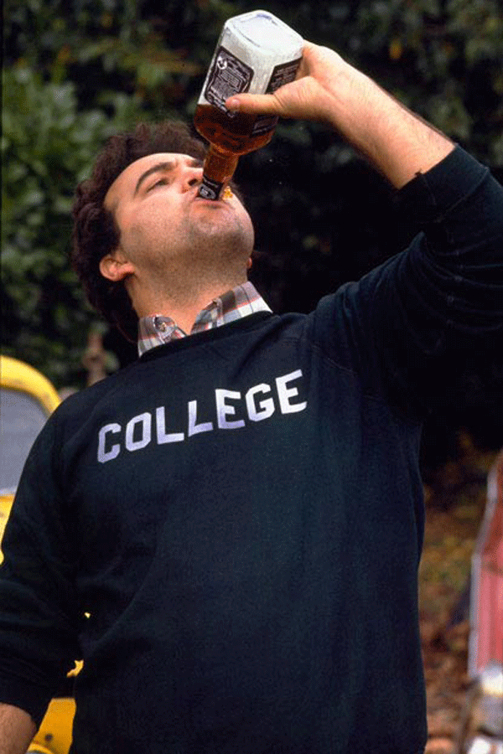
- Deviance?

- Dysfunctional?

- Distressing?

- Dangerous?

