AP Psychology - The Four Lobes of the Brain – Label and note each lobe’s function(s) below the label.
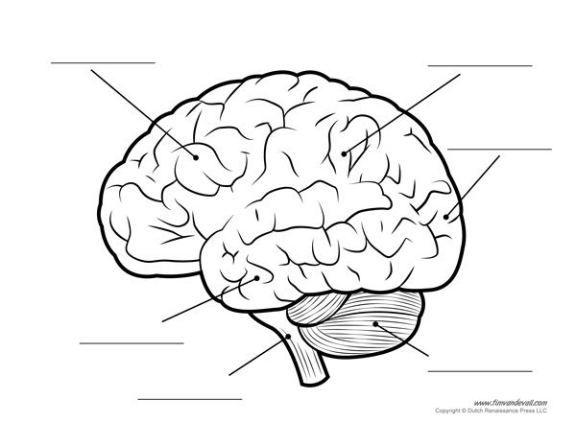

Cerebellum

Brainstem

“F.P.O.T.”
- The frontal lobe is located at the front of the brain and is associated with reasoning, motor skills, higher level cognition, and expressive language. At the back of the frontal lobe, near the central sulcus, lies the motor cortex. This area of the brain receives information from various lobes of the brain and utilizes this information to carry out body movements. Damage to the frontal lobe can lead to changes in sexual habits, socialization, and attention as well as increased risk-taking.

- The parietal lobe is located in the middle section of the brain and is associated with processing tactile sensory information such as pressure, touch, and pain. A portion of the brain known as the somatosensory cortex is located in this lobe and is essential to the processing of the body's senses.

- The temporal lobe is located on the bottom section of the brain. This lobe is also the location of the primary auditory cortex, which is important for interpreting sounds and the language we hear. The hippocampus is also located in the temporal lobe, which is why this portion of the brain is also heavily associated with the formation of memories. Damage to the temporal lobe can lead to problems with memory, speech perception, and language skills.

- The occipital lobe is located at the back portion of the brain and is associated with interpreting visual stimuli and information. The primary visual cortex, which receives and interprets information from the retinas of the eyes, is located in the occipital lobe. Damage to this lobe can cause visual problems such as difficulty recognizing objects, an inability to identify colors, and trouble recognizing words.

