**AP PSYCHOLOGY LONG BREAK ASSIGNMENT**

**(February, 2020)**

**Testing Individual Differences (5-7%)**

*Notice:*

*This assignment serves the purpose of introducing AP Psychology students to key vocabulary and concepts within* ***Testing Individual Differences****, a smaller-weighted unit that can’t fit into our challenging schedule. In order to be prepared for the AP Exam, it is important to be effortful in completing this assignment (I do not recommend doing this in one sitting or even in one week; it is intended to be spaced out over two weeks). Further, this assignment is worth 1/2 a test grade. This assignment is to be completed independently. Copying any aspects of this assignment from classmates is not permitted and will not be accepted.*

**PART I: CRASH COURSE VIDEOS & GUIDES**

**PART II: CHAPTER READING**

**PART III: END OF CHAPTER PRACTICE QUESTIONS**

NAME: ____________________________

DUE: March 2nd, 2020

____/50 POINTS

Controversy of Intelligence: Crash Course Psychology #23

Available at <https://youtu.be/9xTz3QjcloI> or just youtube/google “Crash Course Psychology 23”

1. **Intelligence** is defined as the ability to ___________________________, ____________  
   _______________, and ___________________________ to adapt to new experiences.
2. **Charles Spearman** believed humans have one general intelligence that   
   underlies all factors. What did he refer to this idea as? _______________

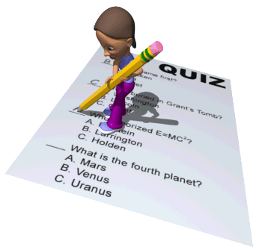

1. **Factor Analysis** is a statistical procedure that identifies clusters of related   
   items (factors) on a test. What hypothetical example does Hank Green   
   give as a demonstration of this?
2. **Savants** exist as an example that counters the idea of general intelligence. What is **savant syndrome**?
3. Complete the chart below for each psychologist’s intelligence theory.

|  |  |  |
| --- | --- | --- |
| **Gardner’s Multiple Intelligences** |  | **Sternberg’s Triarchic Theory** |
| 1. musical | 1. analytical |
| 1. mathematical |
|  |
|  |  |
|  |
|  |
|  |  |
|  |
| 1. existential (not mentioned by Green) |

1. What are the five elements of **creativity**?
2. How would you rate yourself in the following **emotional intelligence** categories? (circle)
   1. Perceiving Emotions [terrible] [poor] [medicore] [good] [excellent]
   2. Understanding Emotions [terrible] [poor] [medicore] [good] [excellent]
   3. Managing Emotions [terrible] [poor] [medicore] [good] [excellent]
3. John Green examines the **history of intelligence** by citing Galton, Binet, Stern, and Terman. Which do you think most advanced the field of intelligence research? Explain.
4. Which element of the **eugenics** movement did you find most disturbing?

Brains Vs. Bias: Crash Course Psychology #24

Available at <https://youtu.be/75g4d5sF3xI> or just youtube/google “Crash Course Psychology 24”

1. An **achievement test** is a test designed to ______________________________________  
   _____________________ while an **aptitude test** is a test designed to _______________  
   ________________________________________________.  
   1. What does Hank Green give as an example of an aptitude test?
   2. What does he give as an example of an achievement test?
2. Why is the **bell curve** used as part of the **standardization** process?
3. **Reliability** is the extent to which a test yields consistent results. What is one way of measuring reliability according to Hank Green’s example?
4. **Validity** is the extent to which a test measures of predicts what it is supposed to. Hank Green goes on to mention a couple specific types of validity. How does **predictive (criterion) validity** differ from **construct validity**?
5. 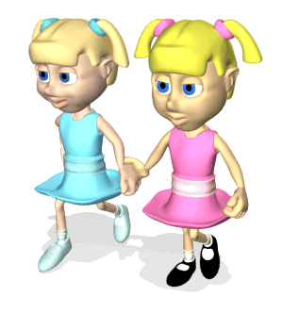Why are **identical twins** useful in determining the impact of nature vs.   
   nurture on intelligence? (note: this isn’t directly answered in the video;   
   you need to think about it)
6. The **J. McVicker Hunt Iranian Orphanage Study** in the 1970s demonstrates that (nature / nurture – circle one) plays a role in the development of language, intelligence, and other factors.
7. What is one example given as evidence of **biased testing**?
8. Overall, do you think your own intelligence is more nature based,   
   more nurture based, or pretty evenly mixed? Why do you think so?

**PART II: CHAPTER READINGS**

*AP PSYCHOLOGY*, SULLIVAN & HAMILTON

(THIRD EDITION)

**TESTING & INDIVIDUAL DIFFERENCES**

CH. 11: 203-218

Students desiring a score of 3 or greater (*this should be everyone*) on the AP Psychology Exam should take notes while reading. Once again, I high recommend using the unit’s 4-Squared Graphic Organizer, too.

|  |
| --- |
| **PART III: END OF CHAPTER PRACTICE QUESTIONS**  *Test your reading comprehension, vocabulary acquisition, and content mastery by answering the questions at the end of the subscribed chapters. Record your answers on the form below. If you are* ***completely*** *stumped by a question, don’t guess – find the concept in the reading.* |

|  |
| --- |
| TESTING & INDIVIDUAL DIFFERENCES  P.219-221 |
| 1 |
| 2. |
| 3. |
| 4. |
| 5. |
| 6. |
| 7. |
| 8. |
| 9. |
| 10. |
| 11. |
| 12. |
| 13. |
| 14. |
| 15. |

