AP Psychology - Keefe Tech

Unit1 Recap - Terms / Ideas – T. Cummings

Research Methods

Psychology = Social SCIENCE
Replication
Experimentation Research / Experimental Design
Hypothesis
Null Hypothesis
Population (n=)
Independent Variable (IV)
Dependent Variable (DV)
Confounding Variables
"They're testing the effect of ______________ on the __________"
Control Group
Experimental Group
Placebo / Placebo Effect
Double Blind Design / Single-Blind Design
Experimenter Bias
Hindsight Bias
Overconfidence
Random Assignment
Research Ethics / IRB
Little Albert Study
Stanley Milgram’s Shock Experiment
Stanford Prison Experiment
Surveys
Framing
Demand Characteristic (drawing conclusions about types of questions, setting, etc…answering in the direction that is helpful to the researcher…or the opposite)
Social Desirability
Operational Definitions
Confederates
Correlational Studies
Positive/Negative Correlation
Correlational Coefficient (-1.0 -- +1.0) (.5 is considered a strong correlation by many texts)
Correlation does NOT equal causation!
3rd Variable Issue (Does ice cream CAUSE shark attacks?)
Spurious Correlations
Case Studies (Examination of 1 person / 1 event)
Kitty Genovese
Jonestown 1978

Statistics in Research Methods

Descriptive Stats - are more appropriate for summarizing, organizing, characterizing data/sample.
- Measures of Central Tendency
  - Mean (μ)
  - Median
  - Mode
- Measures of Variability
  - Standard Deviation (σ)
  - Normal Curve + Percentiles
  - Range

Inferential Stats - more appropriate for comparing differences OR finding statistical significance OR drawing conclusions OR interpreting OR finding if events happened by chance.
- Statistical Significance
- p < .05 (meaning there’s a 95% likelihood the results are NOT due to chance)

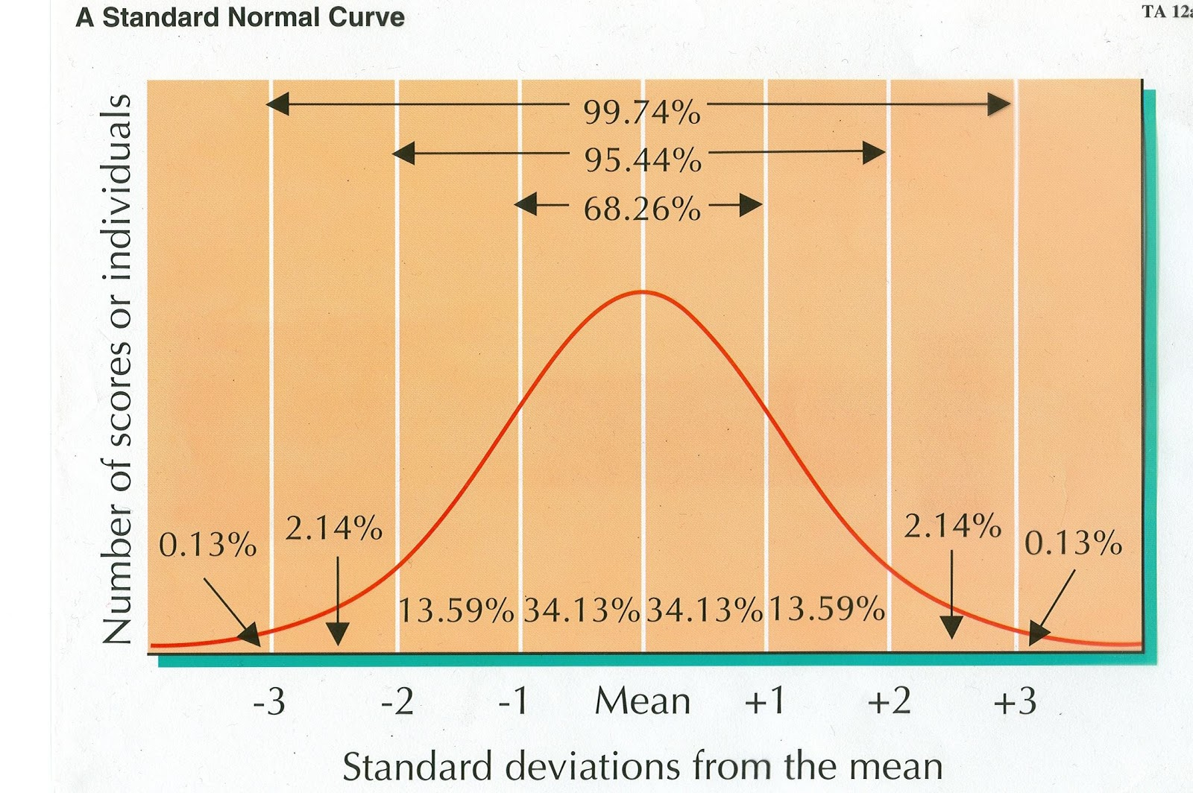
…The skew is the few
