Name_________________________________________________________________________ Block___________

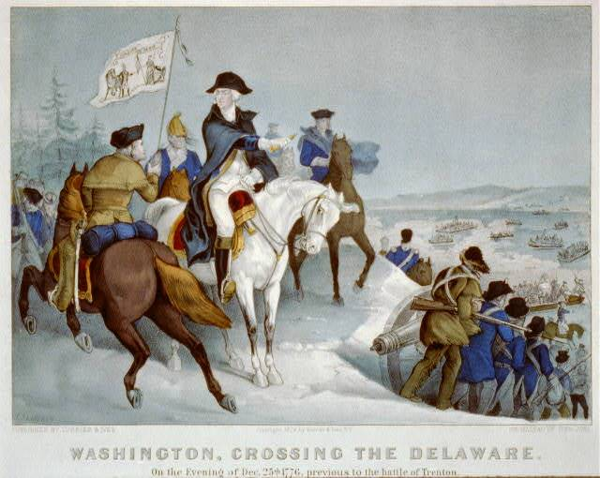
The Crossing – Battle of Trenton Significance Guided Notes

The Battle of Trenton
- The ______________ suffered 4 wounded casualties.
- It is said that in addition, two American soldiers froze to death on the march from the river crossing
- The __________________ suffered 20 killed and around 100 wounded.
- ______________ were captured

- Washington’s troops cross the ____________________________ at night, surprising the German Hessian mercenaries (hired soldiers)
- Americans win an inspiring __________________

The Battle of Trenton: Significance
- Changed the ____________________ of the war
- Washington (in danger of losing his command for his early failures) was now a _______________!
- Given more power by ____________________
- New wave of enlistments began
- Continental Army got what it desperately needed! (took a large store of needed _________________ including 6 Hessian cannons)

The Battle of Trenton demonstrated that:
- An army of poorly trained colonists, ill-clothed, ill-supplied and poorly armed colonists could beat the best soldiers the _________________________ had to offer
- Washington was a resourceful general who planned a strategy in which his soldiers outnumbered and ________________ the Hessians
- The Americans had a chance to __________ the war!!

The Battle of Trenton: Significance
In summary
- Victory saved the _________________________ and boosted morale
- ________________ win an inspiring victory

Extra Notes:

