Name: ____________________________________________ Block_______________ Date_________________
AP Psychology - BioPsych Note Quiz #1

Questions #1-4 – Label the four lobes of the brain below.
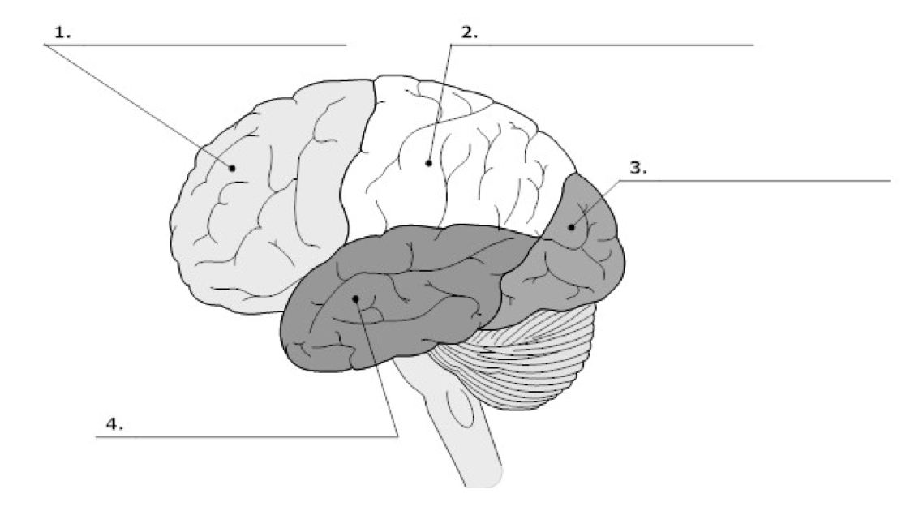

______ 5. What is the main link between the brain and the rest of the body?
A. cerebrum B. spinal cord C. cerebellum D. brain stem

6. Which part of the brain controls blood pressure, heart rate, breathing, and swallowing?
A. brain stem B. limbic system C. cerebral cortex D. thalamus

______ 7. True (T) or False (F): The left side of the brain controls the right side of the body.

8. Which of the following is a function of the frontal lobe?
A. making judgments
B. hearing and smelling
C. reading and speech
D. vision

9. Which part of the brain is the site of intelligence, learning, and judgment?
A. brain stem B. cerebellum C. cerebrum D. limbic system

Part of Brain Function
10. cerebrum A. Coordinates and balances the actions of the muscles
11. cerebellum B. Regulates the flow of information between the brain
12. brain stem and the rest of the body
13. thalamus C. Controls voluntary activities of the body
14. hypothalamus D. Controls hunger, thirst, fatigue, anger, and body temperature
E. Receives and relays messages from the sense organs

