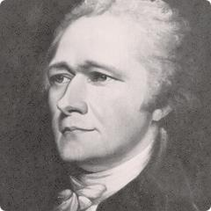
Building a Federal Government
Hamilton’s Financial Plan

United States History (AGS) text pp. 155-157
The Americans text pp. 184-186

Problems:
Why did the U.S. need a financial plan?
Plan:
What was Hamilton’s plan to solve these problems? Be specific.

Opposition:
Who opposed Hamilton’s plan? Why?
Compromise:
What compromise was reached with the opponents of his plan?

Results:
What were the results of Hamilton’s policies?

