Name_____________________________________________ Block______________
Do Now – Politcal Cartoon #1
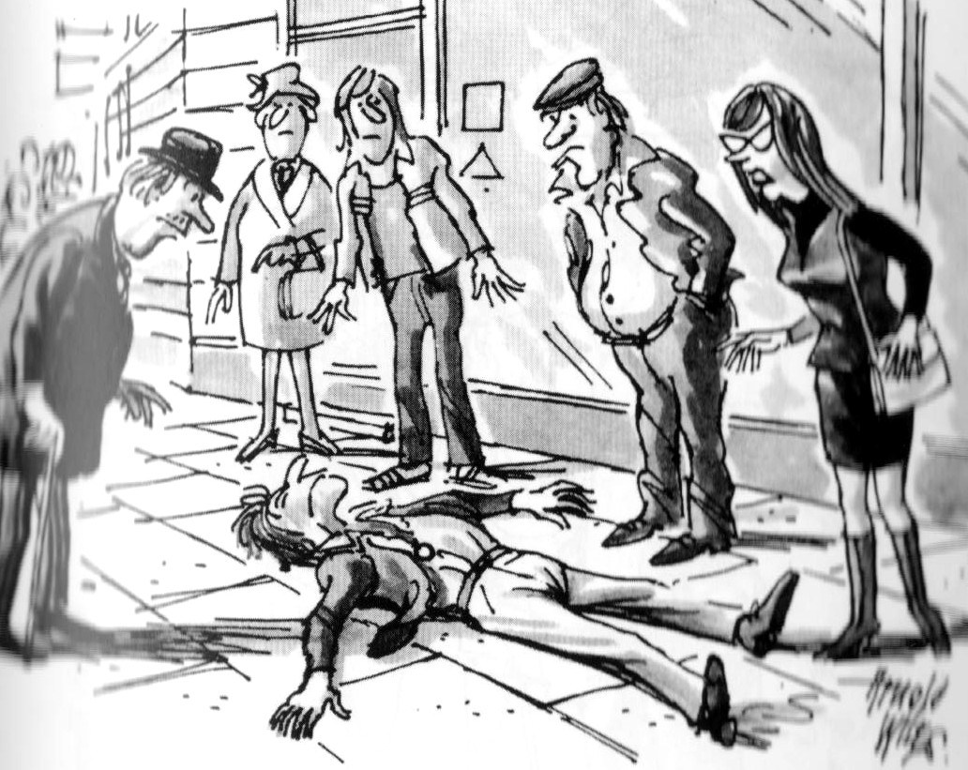

- Describe what you see going on in this cartoon. ________________________________________________________________________________________________________________________________________________________________________________________________________________________________________________________________________

- What social phenomenon is represented here? ________________________________________________________________________________________________________________________________________________________________________________________________________________________________________________________________________

