“American Progress”
by John Gast 1872

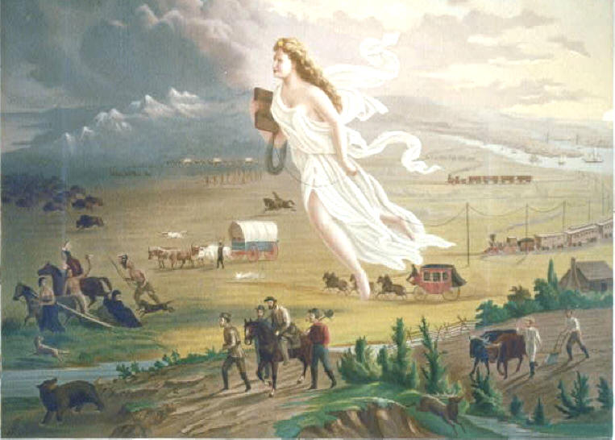

Picture Analysis Worksheet

Study the painting and use the chart below to list the people or animals, objects, and activities that you see in the painting. Be specific.

People or Animal | Objects | Activities

Answer the following questions:
1. What does the woman represent?

2. Why do you think the picture moves from light to dark?

3. What symbols of westward expansion do you see in the painting?

4. How do you think the painter feels about westward expansion?

5. What questions do you have about the painting?

Excerpt from John L. O’Sullivan’s 1839 article, “The Great Nation of Futurity,” The United States Democratic Review, Volume 6, Issue 23, pp. 426-430.

The American people having derived their origin from many other nations, and the Declaration of National Independence being entirely based on the great principle of human equality, these facts demonstrate at once our disconnected position as regards any other nation; that we have, in reality, but little connection with the past history of any of them, and still less with all antiquity, its glories, or its crimes. On the contrary, our national birth was the beginning of a new history, the formation and progress of an untried political system, which separates us from the past and connects us with the future only; and so far as regards the entire development of the natural rights of man, in moral, political, and national life, we may confidently assume that our country is destined to be the great nation of futurity.

- What does O’Sullivan say makes America unique?

2) What does he say connects us to the future?

What friend of human liberty, civilization, and refinement, can cast his view over the past history of the monarchies and aristocracies of antiquity, and not deplore that they ever existed? What philanthropist can contemplate the oppressions, the cruelties, and injustice inflicted by them on the masses of mankind, and not turn with moral horror from the retrospect?

1) O’Sullivan is praising the virtues of the government of the U.S. Which governments might he be talking about when he says that we should, “deplore that they ever existed?”

America is destined for better deeds. ……The expansive future is our arena, and for our history…… with the truths of God in our minds, beneficent objects in our hearts, and with a clear conscience unsullied by the past. We are the nation of human progress, and who will, what can, set limits to our onward march? Providence is with us, and no earthly power can. We point to the everlasting truth on the first page of our national declaration, and we proclaim to the millions of other lands, that "the gates of hell" -- the powers of aristocracy and monarchy -- "shall not prevail against it."
The far-reaching, the boundless future will be the era of American greatness. In its magnificent domain of space and time, the nation of many nations is destined to manifest to mankind the excellence of divine principles; to establish on earth the noblest temple ever dedicated to the worship of the Most High -- the Sacred and the True. Its floor shall be a hemisphere -- its roof the firmament of the star-studded heavens, and its congregation an Union of many Republics, comprising hundreds of happy millions, calling, owning no man master, but governed by God's natural and moral law of equality, the law of brotherhood -- of "peace and good will amongst men.". . .
Yes, we are the nation of progress, of individual freedom, of universal enfranchisement. We must onward to the fulfilment of our mission -- to the entire development of the principle of our organization -- freedom of conscience, freedom of person, freedom of trade and business pursuits, universality of freedom and equality. This is our high destiny, and in nature's eternal, inevitable decree of cause and effect we must accomplish it. All this will be our future history, to establish on earth the moral dignity and salvation of man -- the immutable truth and beneficence of God. For this blessed mission to the nations of the world, which are shut out from the life-giving light of truth, has America been chosen; and her high example shall smite unto death the tyranny of kings, hierarchs, and oligarchs, and carry the glad tidings of peace and good will where myriads now endure an existence scarcely more enviable than that of beasts of the field. Who, then, can doubt that our country is destined to be the great nation of futurity?

- How does O’Sullivan depict the relationship between the U.S. and God?

2) What does O’Sullivan say is America’s role in the world?

