Main Idea

As you read pages 338-341, fill out the table below
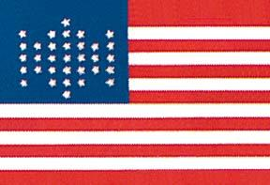
Union Strengths | Confederate Strengths
Union Strategy | Confederate Strategy

