Name__________________________________________________Block_____Date_________________
That Was
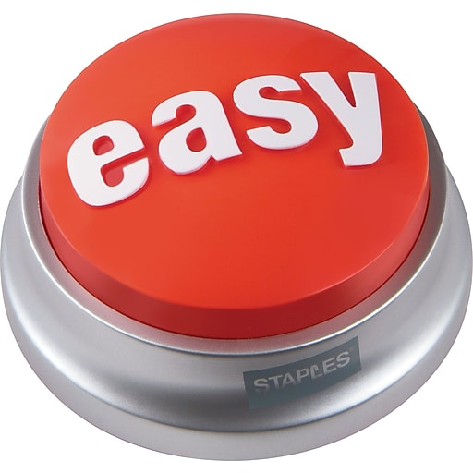

Do Now - Video

- Unconditioned Stimuli =

- Unconditioned Response =

- Conditioned Stimuli =

- Conditioned Response =

Name__________________________________________________Block_____Date_________________
That Was

Do Now – Video

- Unconditioned Stimuli =

- Unconditioned Response =

- Conditioned Stimuli =

- Conditioned Response =

