Name Block Date
CNN10 – “3,2,1” -- 9/11 Edition
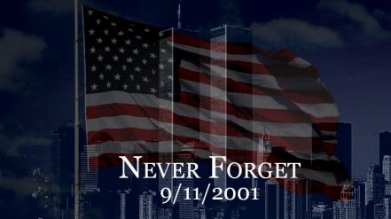
Three Facts I Learned:

Two Questions I Have:

One Word to Sum It All Up:

