Name_________________________________________Block_______________________Date__________
Life in the New England Colonies
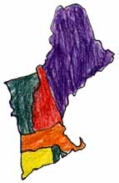

The New England colonies include Connecticut, Massachusetts, New Hampshire and Rhode Island. The lifestyle of New England’s people was greatly impacted by both its geography and climate.
New England’s economy depended on the environment. Its location near the Atlantic Ocean along a jagged coastline determined how people made a living. People in New England made money through fishing, whaling, shipbuilding, trading in its port cities and providing naval supplies. One of the busiest port cities was Boston.
People in New England could not make a living from farming because most of the land was not suited to farming due to the hilly terrain and rocky soil. The nature of the soil was partially caused by the Appalachian Mountains. Another factor that made farming for profit difficult was climate; New England experienced moderate summers and cold winters. The growing season was simply too short to make farming profitable and most farms were small family ones. So rather than farming, many people not involved in industries involving the water were either skilled craftsman or shopkeepers.
Towns and villages were very important in the daily lives of New Englanders. Their social lives revolved around village events and attending church. The Sabbath or Sunday was a high point of the week. Work was not allowed and it provided an opportunity to visit one another. Many of the New England colonies were founded by religious reformers and separatists searching for religious freedom.
Civic events were also central to New England life. Town meetings determined answers to important questions about running the colony. Once a year all adult males met to participate in this decision making process. These town meetings were an important step in forming the democracy we have today.

1. Which colonies were in New England?

2. How did people make a living?

3. Describe the land.

4. What group of people founded New England?

5. Why were town meetings important?

The Middle Colonies

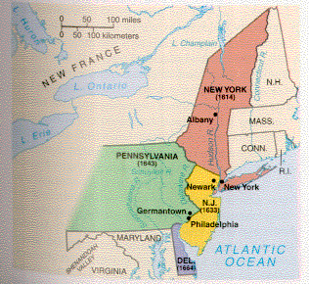

The Mid-Atlantic Colonies are Pennsylvania, New York, New Jersey and Delaware. Just like in New England, the environment greatly impacted the way people who lived in the middle colonies made a living and went about their daily lives. There are some similarities between New England and the Mid-Atlantic such as the nearby Appalachian Mountains but there are even more differences.
The first difference between New England and Mid-Atlantic colonies was the quality of the land. The Middle colonies had rich farmland and a moderate climate which made farming much easier than it was in New England. Many people made their living raising livestock or growing grain. Due to the ease of farming these colonies were able to provide food for their own people and to send to the other colonies; the Middle colonies became known as the breadbasket colonies.
Land in the middle colonies also consisted of coastal lowlands (or the Coastal Plain) which contained harbors and bays with wide, deep rivers. Part of the area is also known as the Piedmont. The location along the Atlantic Coast also allowed people in the Mid-Atlantic colonies to make a living through fishing. Those who did not make a living by farming or fishing were able to find work as either skilled or unskilled workers.
People in the middle colonies had varied lifestyles and participated in many different religions. The reasons for the variety of cultures is due to the fact that the people of the Middle colonies came from many different countries. Despite this the variety of people’s backgrounds, social life still revolved around the village or city one lived in. Market towns were extremely important in the Middle colonies because people needed to go to town to trade the products they grew or made.

1. Which colonies made up the Mid-Atlantic?

2. Describe the Mid-Atlantic. What was the land and climate like? How did people make a living?

Southern Colonies
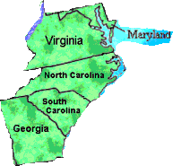

As with the other colonial regions, the lifestyle of the south is directly related to its climate and geography. The south shares much in common with the other two colonial regions but it has several distinct characteristics that make the south unique.
Some of the important geographic features of the south include the Appalachian Mountains, the Piedmont, and the Atlantic Coastal Plain. The presence of good harbors and rivers along with its hot, humid climate dictated how the people of the south made a living. Like in the middle colonies, southerners made a living through farming.
However these farms were much larger and were called plantations. Since these individually owned farms were so large, the plantations required a large labor force. To run their farms and produce the cash crops (tobacco, rice, and indigo) they needed to made a profit, plantation owners began using forced labor, or slavery. Slaves were workers who belonged to their owners and had no freedom. Another type of labor used in the south were indentured servants. These were people who had their passage to the New World paid for and were working for free until their debt was paid back. Plantation owners typically had a great deal of money and lived in mansions; most residents of the south who did not have as much money made a living with small family farms or by producing wood products.
The economy of the south with its large plantations also affected the social and political life of the south. Plantations were typically self-sufficient, providing everything the people living on it would need so there was no need for cities, towns or schools. Even church services occurred on the plantations; most southerners attended the Church of England, the Anglican Church. Since there was no need for towns or cities, governments and politics weren’t run as they were in New England through town meetings. In the south, politics were determined by county.

1. What 2 things influence the lifestyle in the South.

2. What were many of the farms like in the Southern colonies?

3. What was a slave?

4. What church did many Southerners attend?

***Extension Assignment – A Letter Home ***

Directions – Imagine it’s the year 1635 and you have recently moved to one of the colonies a year ago. You miss your family and you want them to know how you are doing in ‘the new world’. Write a letter home (England) to your family describing your life in one of the three English colonial regions described above (New England, Middle Colonies, or Southern Colonies). Use information from your notes and from the paragraphs above to accurately describe your experience. Because it is very expensive to send a letter back across the Atlantic Ocean, you must get your monies worth and write at least ten (10) complete sentences describing your life. Write this letter neatly on a separate sheet of paper.

