Name_________________________________________ Block____________
Do Now - Can You Label the 13 Colonies?
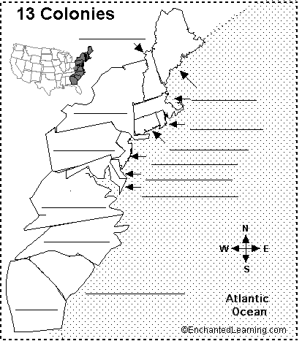
New Hampshire | Massachusetts | Connecticut | Rhode Island
Delaware | New York | Pennsylvania | New Jersey
North Carolina | Georgia | South Carolina | Virginia
Maryland

