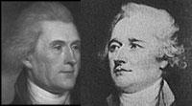
Political Parties Grow

With the ink barely dry on the Constitution, distinct political parties were already forming in the United States. The intense debate over ideas that had surrounded the writing of the Constitution shaped the rise of political parties in the new nation.

Directions: Write each detail under the correct heading below. Use pages 184-187 to complete the chart below.

Answer Bank

- Led by Alexander Hamilton
- Wanted to base the economy on farming
- Led by Thomas Jefferson
- Favored a strong centralized government
- Supported a loose construction of the Constitution
- Were pro-British

- Supported a strict construction of the Constitution
- Believed the National bank was unconstitutional
- were pro-French
- Supported the Bank of the United States
- Wanted to base economy on industry and trade

Federalists | Democratic Republicans

