Name: _____________________________________________Block_______________Date______________
US History I Keefe Tech
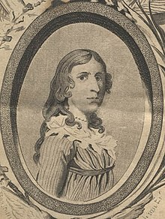
PVT Deborah Sampson, Continental Army
Deborah Sampson (December 17, 1760 – April 29, 1827) was a Massachusetts woman who disguised herself as a man in order to serve in the Continental Army during the American Revolutionary War. She is one of a small number of women with a documented record of military combat experience in that war.
Under the name "Robert Shirtliff" of Uxbridge, Massachusetts, Sampson fought in several battles. During her first battle, on July 3, 1782 outside Tarrytown, New York, she took two musket balls in her thigh and sustained a cut on her forehead. She begged her fellow soldiers to let her die and not take her to a doctor (out of fear she'd be discovered), but a soldier put her on his horse and took her to a hospital. The doctors treated her head wound, but she left the hospital before they could attend to her leg. Fearful that her identity would be discovered, she removed one of the balls herself with a pen-knife and sewing needle, but the other one was too deep for her to reach. Her leg never fully healed and she carried one of the musket balls for the rest of her life.
PVT Deborah Sampson served 17 months in the army and was honorably discharged at West Point, New York, in 1783.
Her legacy lives on today. The town of Sharon, MA now memorializes Sampson with a statue in front of the public library, the Deborah Sampson Park, and the "Deborah Sampson Gannett House." In 1906, the town of Plympton, Massachusetts placed a boulder on the town green, with a bronze plaque inscribed to Sampson's memory. During World War II, the Liberty Ship S.S. Deborah Gannett was named in her honor. It was laid down March 10, 1944, launched April 10, 1944 and scrapped in 1962.
As of 2000, the town flag of Plympton incorporates Sampson as the Official Heroine of the Commonwealth of Massachusetts.
Reading Questions
- Did women fight in combat during the American War for Independence?
- What happened to Deborah Sampson during her first battle?
- What words come to mind when describing Deborah Sampson’s biography? (answers will vary)
- What does Sampson’s story teach us? (answers will vary)

