Name__________________________________________________________Block_________Date_____________
Do Now – Map Skills – European Colonies in North America in 1700
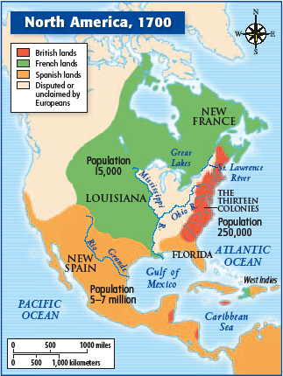
- What European country controlled the east coast of North America (The 13 Colonies)?

- What European country controlled the territory west of the Mississippi River and much of modern day Canada?

- What European country controlled the North American southwest, modern-day Mexico, Central-America, and the majority of South America?

- Why do you think these European Countries wanted to claim distant territories (colonies) in North and South America?

- What do you think will happen as the result of disputed territories?

