Name____________________________________________Block______________Date________
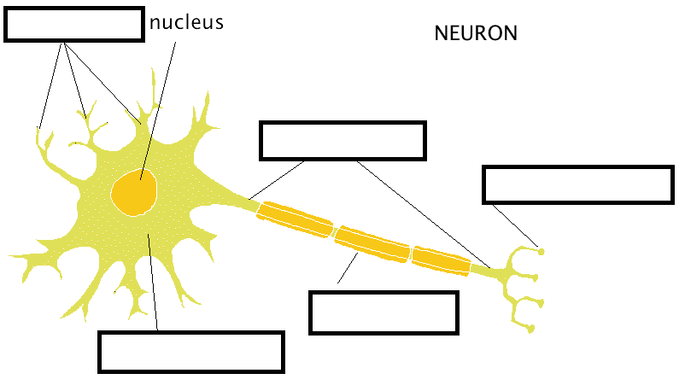
Do Now – Label a Typical Neuron

Name____________________________________________Block______________Date________
Do Now – Label a Typical Neuron
Matching:
# |  | letter
1 | Form junctions with other cells, sends messages |  | - Dendrites
2 | Covers the axon of some neurons, acts as an insulator, and helps speed up neural impulses |  | - Soma / Cell Body
3 | The cell’s life-support center |  | - Axon
4 | The cell’s ears, receives messages from other cells. |  | - Myelin Sheath
5 | Passes messages away from the cell body to the terminal branches and on to other neurons, muscles, or glands. Myelinated. |  | - Terminal Branches / Buttons

Matching:
# |  | letter
1 | Form junctions with other cells, sends messages |  | - Dendrites
2 | Covers the axon of some neurons, acts as an insulator, and helps speed up neural impulses |  | - Soma / Cell Body
3 | The cell’s life-support center |  | - Axon
4 | The cell’s ears, receives messages from other cells. |  | - Myelin Sheath
5 | Passes messages away from the cell body to the terminal branches and on to other neurons, muscles, or glands. Myelinated. |  | - Terminal Branches / Buttons

