Name Block Date
Do Now – Loyalist or Patriot
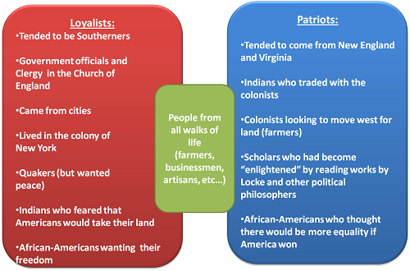
Directions – using the chart above as a guide, circle the correct answer, Loyalist, Patriot, or Both.
- Were mostly farmers and wanted more land in the west… Loyalist / Patriot / Both
- Tended to be Southerners… Loyalist / Patriot / Both
- Businessmen… Loyalist / Patriot / Both
- Were inspired by Enlightenment philosophers… Loyalist / Patriot / Both
- Farmers… Loyalist / Patriot / Both
- Native Americans who traded with colonists… Loyalist / Patriot / Both
- New Yorkers… Loyalist / Patriot / Both
- New Englanders… Loyalist / Patriot / Both
- Virginians… Loyalist / Patriot / Both
- Lived in cities… Loyalist / Patriot / Both
- If you were alive in 1775, would you be a Patriot or a loyalist? Why? __________________________________________________________________________________________________________________________________________

