Name Date Block
The Aftermath of the French & Indian War
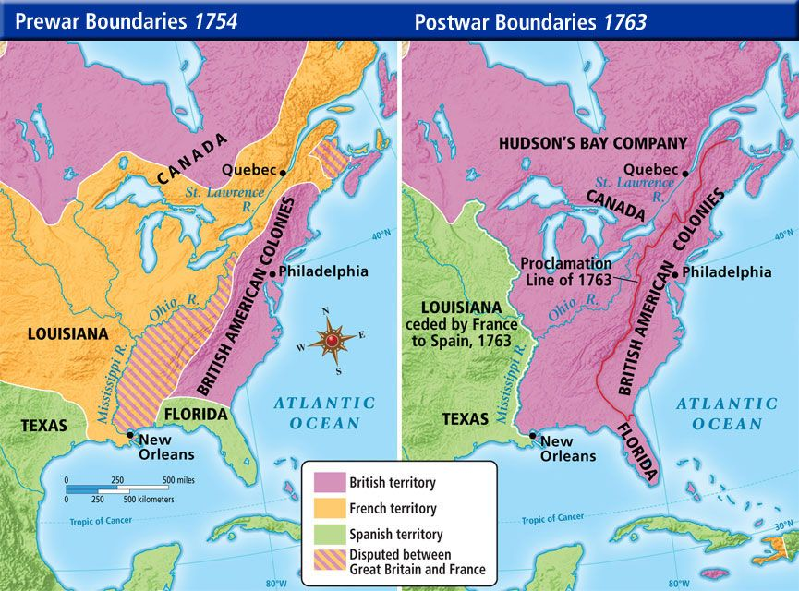
Do Now: Predict 3 factors that might have lead the colonists to begin desiring independence from England.

