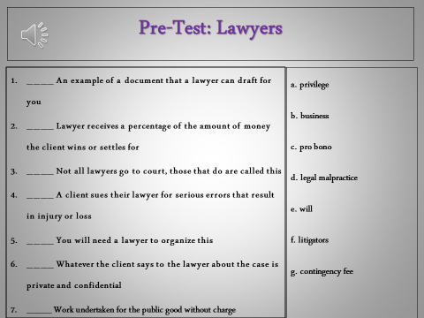
Name_____________________________________________________________Block____________Date__________________
Do Now – Pre-Test: Lawyers

