Name___________________________________________________Block_____________Date__________________
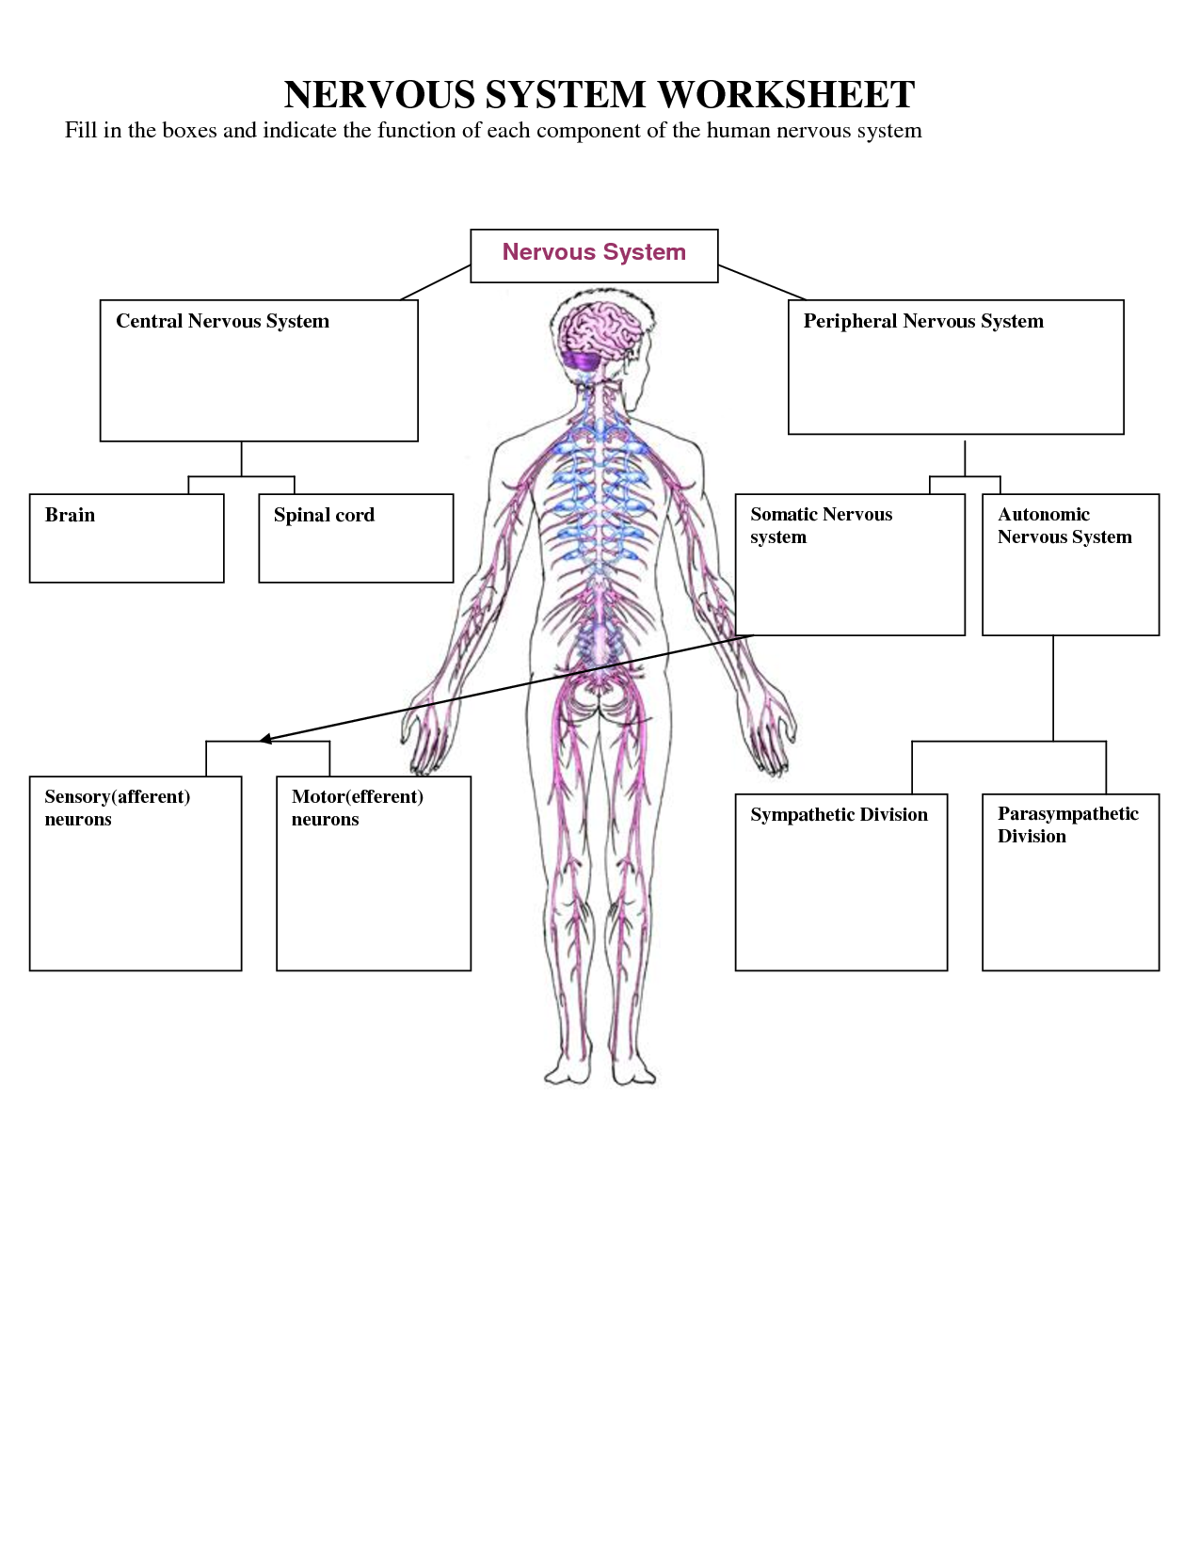
AP Psychology – BioPsych
Reviewing the Nervous System
- Brain and Spinal Cord = ________________________________________
- Consists of the nerves and ganglia outside the brain and spinal cord = _________________
- Associated with the voluntary control of body movements via skeletal muscles. The somatic nervous system consists of afferent nerves or sensory nerves, and efferent nerves or motor nerves = _______________________________________
- Carry nerve impulses from sensory stimuli towards the central nervous system and brain = ____________________________________________________
- carry neural impulses away from the central nervous system and towards muscles to cause movement = _______________________________
- A control system that acts largely unconsciously and regulates bodily functions such as the heart rate, digestion, respiratory rate, pupillary response, urination, and sexual arousal = ___________________________________
- Activates what is often termed the fight or flight response = _________________________________________
- Conserves energy as it slows the heart rate, increases intestinal and gland activity, and relaxes digestive muscles in the gastrointestinal tract = __________________________________________

