Name________________________________________________________________________________Block________________________
Do Now: Map Skills - Answer the map questions below and write your KEYS on the back!
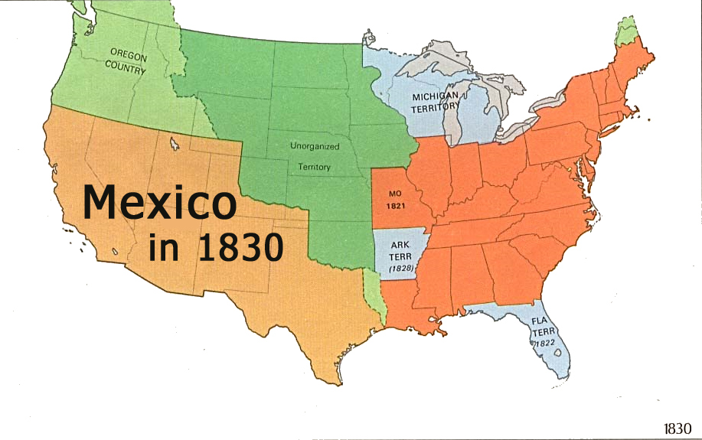
- Who controlled (owned) Texas in 1830?

- What modern US states, or parts of states, did Mexico own in 1830? (10)

