Name__________________________________________________ Block_______________Date_________

AP Psychology - Unit 3: Sensation & Perception
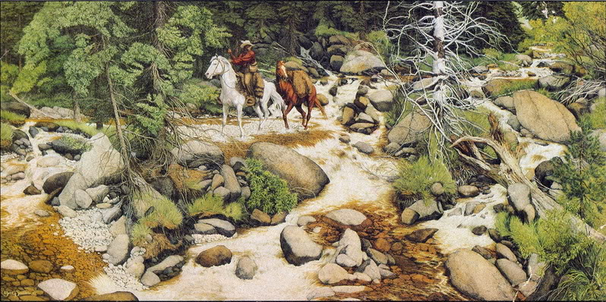
Do Now - The Forrest Has Eyes

Explain how this painting provides an example of…

- Bottom-Up Processing…

- Top-Down Processing …

