Name_____________________________________________Block____Date________________
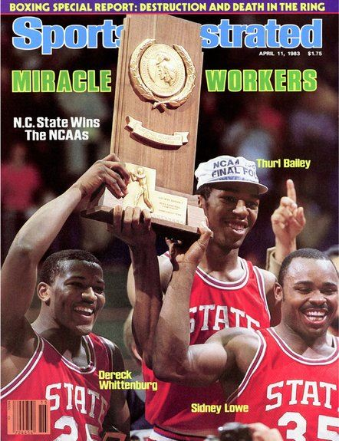
Do Now – Pre-Battle of Trenton
Do the Best Teams Always Win? Can you think of an example of when they didn’t?
(Respond to this question in two complete sentences)
___________________________________________________________ ___________________________________________________________ ___________________________________________________________ ___________________________________________________________ ___________________________________________________________ ___________________________________________________________ ___________________________________________________________ ___________________________________________________________

Name_____________________________________________Block____Date________________
Do Now – Pre-Battle of Trenton
Do the Best Teams Always Win? Can you think of an example of when they didn’t?
(Respond to this question in two complete sentences)
___________________________________________________________ ___________________________________________________________ ___________________________________________________________ ___________________________________________________________ ___________________________________________________________ ___________________________________________________________ ___________________________________________________________ ___________________________________________________________

Name_____________________________________________Block____Date________________
Do Now – Pre-Battle of Trenton
Do the Best Teams Always Win? Can you think of an example of when they didn’t?
(Respond to this question in two complete sentences)
___________________________________________________________ ___________________________________________________________ ___________________________________________________________ ___________________________________________________________ ___________________________________________________________ ___________________________________________________________ ___________________________________________________________ ___________________________________________________________

