Name: January 9th, 2019
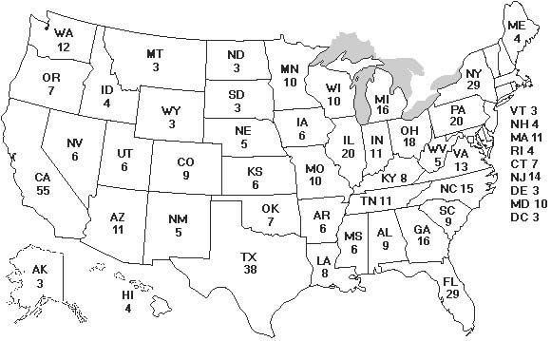
Do Now
Using your notes, answer the following questions.

- Massachusetts has 11 electors and, therefore, 11 Electoral College points. Pennsylvania has 20 electors and, therefore, 20 Electoral College points. How are such numbers assigned to states?

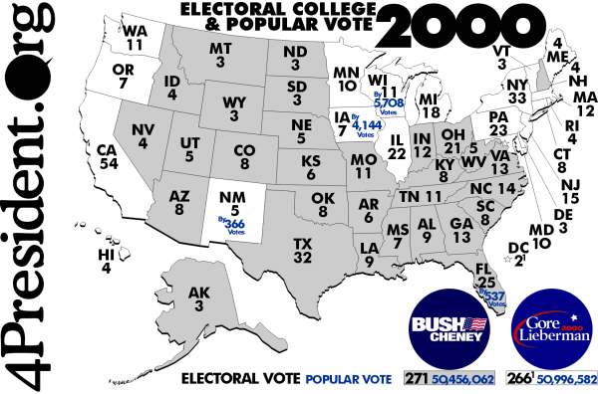
- How did the 12th Amendment to the United States Constitution alter the way by which the United States elects a president and vice-president?

- In the 2000 Presidential Election, D-Al Gore won the popular election by ~500,000 votes over R-George W. Bush, yet lost the presidential election. Explain how this is possible.

Popular Vote in Massachusetts
Presidential Candidate A | Presidential Candidate B
3,000,000 | 3,000,001

- According to the chart above, who would receive Massachusetts’s 11 Electoral College points?

- Look at the two Electoral College maps. The top one is from 2016. The bottom one if from 2000. Explain how/why Massachusetts LOST an Electoral College point.

