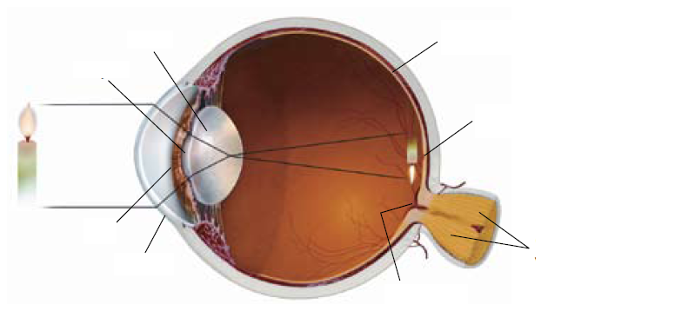
Label and take notes on the Eye – Neurology

