Name_______________________________________ Period__________
Do Now: Political Cartoon – “Executive Pruning”
Directions: Study the political cartoon and answer the questions below. Note, this is a political cartoon and may be interpreted differently; therefore, answers will vary. USE COMPLETE SENTENCES!
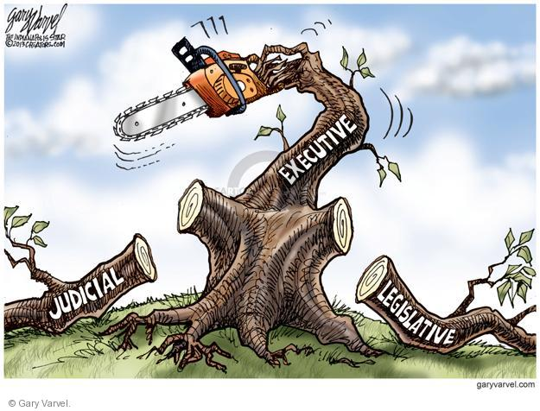

- What do you see in this political cartoon? ___________________ _______________________________________________________ _______________________________________________________ _______________________________________________________ _______________________________________________________ _______________________________________________________ _______________________________________________________ _______________________________________________________

- What event and/or idea does this political cartoon refer to? ____ _______________________________________________________ _______________________________________________________ _______________________________________________________ _______________________________________________________ _______________________________________________________
- What point do you feel the cartoonist is trying to make? ______ ______________________________________________________
_______________________________________________________ _______________________________________________________ _______________________________________________________ _______________________________________________________ _______________________________________________________ _______________________________________________________ _______________________________________________________
_______________________________________________________ _______________________________________________________
- What information do you think is essential to know in order to understand this political cartoon? _________________________ _______________________________________________________ _______________________________________________________ _______________________________________________________ _______________________________________________________ _______________________________________________________ _______________________________________________________ _______________________________________________________ _______________________________________________________
- If you could change anything in this political cartoon to make it better and/or easier to understand, what would you add and/or change? ______________________________________________ _______________________________________________________ _______________________________________________________ _______________________________________________________ _______________________________________________________ _______________________________________________________

