Name: AP Psychology
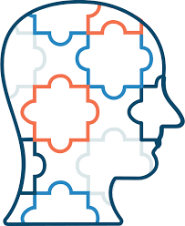
Block: Pop Quiz
Reading, Ch. 2 – 40-42

Directions - using your notes from class or via your reading, answer the following questions.

- _________________________________ refers to the idea that humans are born with a tendency toward certain behaviors or characteristics, but only a tendency (or a ‘push’).

- Very few human traits or conditions are truly genetically determined. Provide one example of a genetically determined condition: _____________________________________________________

- ____________________________ refers to the amount of difference between individuals that seems to be accounted for by heredity.

Name: AP Psychology
Block: Pop Quiz
Reading, Ch. 2 – 40-42

Directions - using your notes from class or via your reading, answer the following questions.

- _________________________________ refers to the idea that humans are born with a tendency toward certain behaviors or characteristics, but only a tendency (or a ‘push’).

- Very few human traits or conditions are truly genetically determined. Provide one example of a genetically determined condition: _____________________________________________________

- ____________________________ refers to the amount of difference between individuals that seems to be accounted for by heredity.

