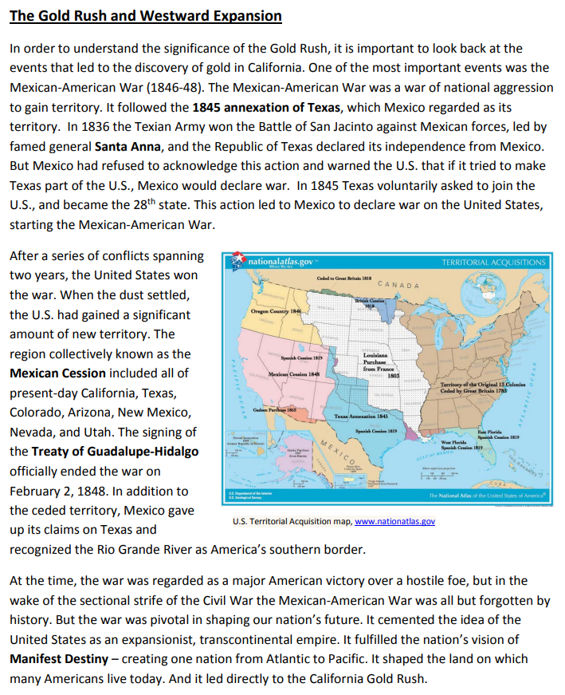

Word Bank: Santa Anna Manifest Destiny Mexican Cession Annexation of Texas Treaty of Guadalupe-Hidalgo

