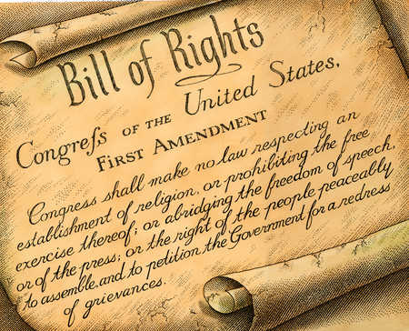
Guided Notes: The Bill of Rights

- The ________________________________________ was added to the Constitution helped persuade opponents (Anti-Federalists) to ____________________ (approve) it

- It protected the individual ________________ of citizens (Freedom of religion, right to keep and bear arms, etc.)

First Amendment
- The First Amendment protects the 5 basic civil ______________ of citizens
- Guarantees freedom of religion, speech, the ________________ assembly, and petition
Second Amendment
- The Second Amendment ensures the right of the people to keep and bear _________________
- Its interpretation is at the center of the current gun ________________ debate
Third Amendment
- “No soldier shall, in time of peace be quartered in any house, without the consent of the owner, nor in time of war, but in a manner to be prescribed by law.”
- This means the military cannot ________________ soldiers in people’s homes unless approved by law
Fourth Amendment
- The Fourth Amendment limits _____________________ searches and seizures by local, state, and federal law
- Protects the _________________ of the homes and property of citizens
Fifth Amendment
- The Fifth Amendment requires a _________________ jury to initiate federal prosecution
- Protects against ________________-_______________________________(right to remain silent)
- You may not be tried twice for the same ___________________ (double jeopardy)
Sixth Amendment
- Anyone accused of a crime is entitled to a __________________ and fair trial by ________________
- Also guarantees explanation of the charges, access to witnesses, and right to a _________________

Seventh Amendment
- The Seventh Amendment guarantees a trial by jury in _______________________ (civil court)
- Established a judicial process to _____________ for money, property, or personal injury
- A civil trial differs from a criminal trial
Eighth Amendment
- Protects the accused from cruel and unusual ___________________ and excessive ________________ or fines
Ninth Amendment
- Rights not stated in the Constitution and not forbidden by the Constitution belong to the ________________
- Establishes possible rights that the Constitution’s framers couldn’t anticipate (such as the right to die controversy)
Tenth Amendment
- States that any powers not given to the federal government by the Constitution belong to the _____________________ and __________________

Bill of Rights

In 5 Words or Less

- Using your notes, summarize each amendment in 5 words or less.

- You may use an acronym for Amendments #1, 5, and 6 because they contain multiple components.

- _____________________________________________________________________

- _____________________________________________________________________

- _____________________________________________________________________

- _____________________________________________________________________

- _____________________________________________________________________

- _____________________________________________________________________

- _____________________________________________________________________

- _____________________________________________________________________

- _____________________________________________________________________

- _____________________________________________________________________

