Name: Block: Date:

Industrialization & Reform Movements of the 1800s ‘Multimedia Quest’

Task #1 - Video: Industrial Revolution - https://bit.ly/2E2i1u2
Directions: Watch the following videos on your devices and answer the corresponding questions.
- Before the Industrial Revolution, how were all goods made?

- In what country did the Industrial Revolution begin?

- Describe how the mills made their way to America.

- By the end of the 19th century, where did most Americans move to and live?

- How did the Assembly Line affect prices of products?

- How did the Assembly Line affect the conditions of the working class?

- How did workers try to get better working conditions and wages?

- Who benefitted the most from the Industrial Revolution?

- [PREDICTION/BONUS]: Can you think of any other effects (good or bad) of industrialization?

*Note the Progressive Era made strides to regulate industry and combat the bad effects of industrialization*

Task #2 – Website Research: 5 Effects of Industrialization -http://goo.gl/vgfJln

Directions – Using your devices, access the website and complete the list of four positive and four negative effects of the Industrial Revolution.

Industrial Revolution: Industrialization refers to the development of machine production of goods and new energy resources. Industrialization had many positive and negative effects on the citizens of Europe in the 18th and 19th centuries.
Positive Effects: | Negative Effects:
- New Job Opportunities | 1. Overcrowding in Cities  2.  3.  4.

Task #3 – The Americas textbook: Guided Reading

Main Idea:

Vocabulary: How were these people involved in the reform movements of the 1880’s?

Charles G. Finney:
Ralph Waldo Emerson:
Henry David Thoreau:
Dorothea Dix:

Tent Revival Meeting of the Mid-1800s
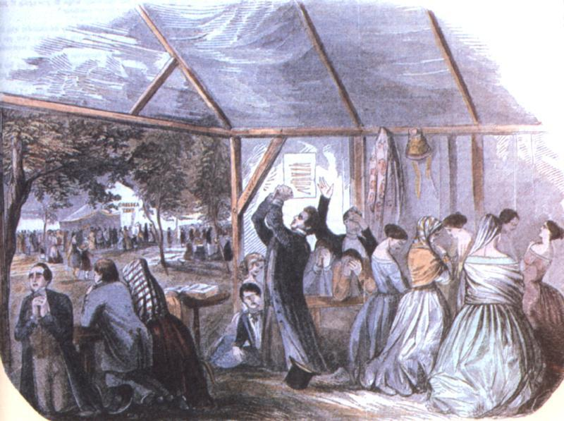

As you read about reform movements on pages 240-245, answer the questions below.

Late 1700s:
New religious and philosophical movements emerge during the Second Great Awakening.
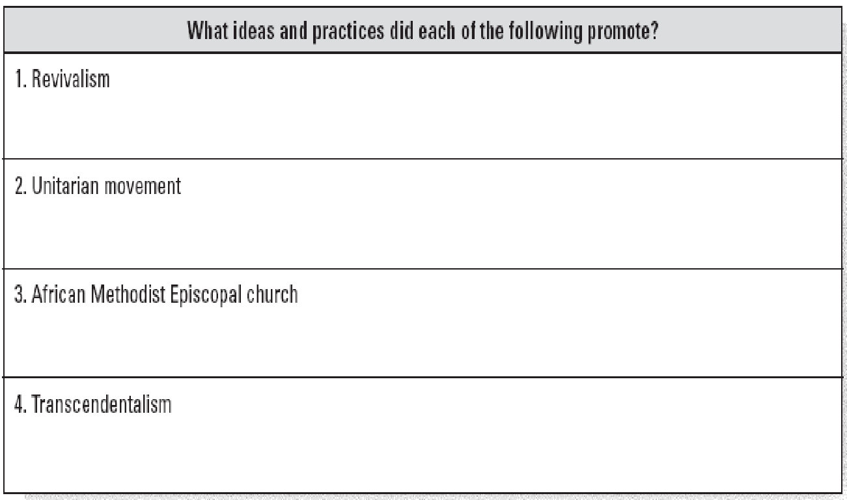
Mid-1800s:
By this time, Americans from numerous religious and philosophical movements
joined together to fight the social ills that were troubling the nation.

