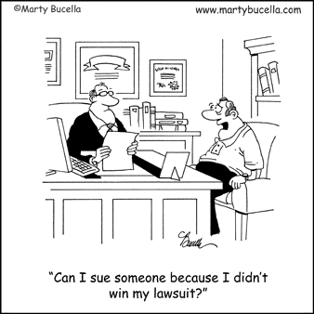
Lawyers (Part 2)
How Do You Find a Lawyer?
- BEST way is to ask for a ________________ from someone who has had to deal with a __________ legal issue
- Use the Internet (Be careful)
- Use a local lawyer ________________ service (Mass. Bar Assoc.)
- Consult the Martindale-Hubbell Law (Legal Library) [martindale.com]

Bar Associations
- Responsible for the _______________ of the legal profession in their jurisdiction
- Organizations that _____________ lawyers
- Provide services to _________ you decide if you need a lawyer

What if you cannot afford an Attorney?
There are some options:
- You may qualify for __________ legal assistance
- A lawyer may take on a legal case _______ _____________ for a good cause
- Pro bono refers to legal work that is performed voluntarily and free of charge
- When a lawyer works pro bono, he or she is said to be working for the _____________ good

Contingency Fee
- Some attorneys take cases on a contingency fee (lawsuits)
- The attorney will receive a certain ____________ of any money (settlement) the client wins in the case
- If the client does not win the case, the lawyer does _____ receive any money
Do Your Homework
- It is wise to __________ more than one lawyer to take your case
- Use these meetings to judge the differences between:
- their ______________
- their _______________ in your type of case
- how you think you will be able to work with each of them

Legal Fees:
Good Questions to Ask
- What is the estimate of the total ______________?
- How much does each person charge per hour?
- Is a ____________ (down payment of the total fee) required?
- Are there any other _____________ you should be aware of? (court costs, filing fees, etc.
Working with Your Lawyer
Making Decisions
- A good attorney will give you advice, but YOU must make the final ____________.
- It’s your life and your future – and NOT your lawyer’s
Examples:
- To sue or not to sue
- To accept or to reject a ______________ offer
- To take the __________ or remain silent
- To ___________ guilty or not guilty
Making Decisions
- The attorney’s job to help you understand what is going on; to keep you _______________.
- It is your job to ask ___________ questions as needed
- If you are not satisfied, you may ____________ your lawyer
- But once in court, the ______________ will permit a change in lawyers ONLY for a very good reason

Attorney-Client Privilege
- ______________ is essential to the attorney-client relationship
- This privilege encourages clients to speak openly and honestly to their attorneys
- This means that whatever you tell your attorney about your case is secret and ________________
- This privilege prevents a lawyer from revealing the client's information without ____________________

Conduct of Lawyers
- There has been a great deal of concern about the conduct of lawyers today
- Like other professionals, lawyers can be sued by clients for serious errors that result in injury or loss
- Clients can file a(n) __________________ __________________ against an attorney (if they believe the attorney has acted irresponsibly and mishandled the case)
- Lawyers must also follow certain standards of __________
- These standards are set out in a Code of Professional _______________ that are enforced by the state bar association
- Lawyers who violate standards of conduct may be reprimanded, suspended, or ____________ (no longer has a license to practice law)

