Lawyers (Part 3)
The Pros
of Hiring an Attorney
- ___________________________, direction, and guidance on complex legal matters that most people do not understand
- Complex issues may require__________________________that can only be undertaken by an attorney
- Attorney can ________________________ at trial, _______________________ for the type of questions you may be asked at trial, and how to best answer them.
- Being represented by an attorney may provide you the ________________________________ a complex, contested claim at trial.

The Cons
of Hiring an Attorney
- __________________________________
- _____________________________ in every type of legal matter (btw - documents are often prepared by the attorney’s __________________.)
- _____________________________ may “learn on the job” at the unsuspecting client’s expense.
- Some legal matters can often be easily accomplished _______________________________.

What’s the Trouble
with Lawyers?
Too many laws leads to disputes and problems that cannot be solved …
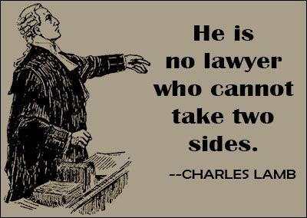
- which has lead to too many lawyers
- which has lead to too many lawsuits
- - which becomes a sort of legal extortion .(Pay me money or I will sue you!)
- Is there a need for tort reform? (Get rid of frivolous lawsuits)
- Loser pays – Do you think it is a good solution?

Video: The Trouble with Lawyers (Notes)

A Need for Tort Reform? (Further Arguments For/Against to follow…)

