Name___________________________________Block_____Date____________
Do Now – Memory
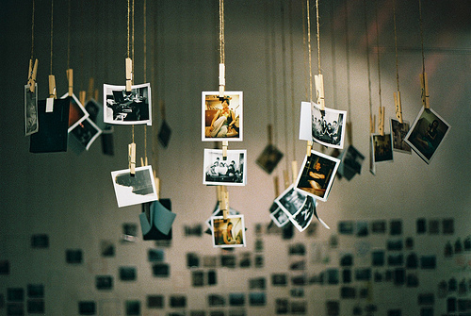

- What is your earliest memory, and…

- why do you think you remember that in particular?

