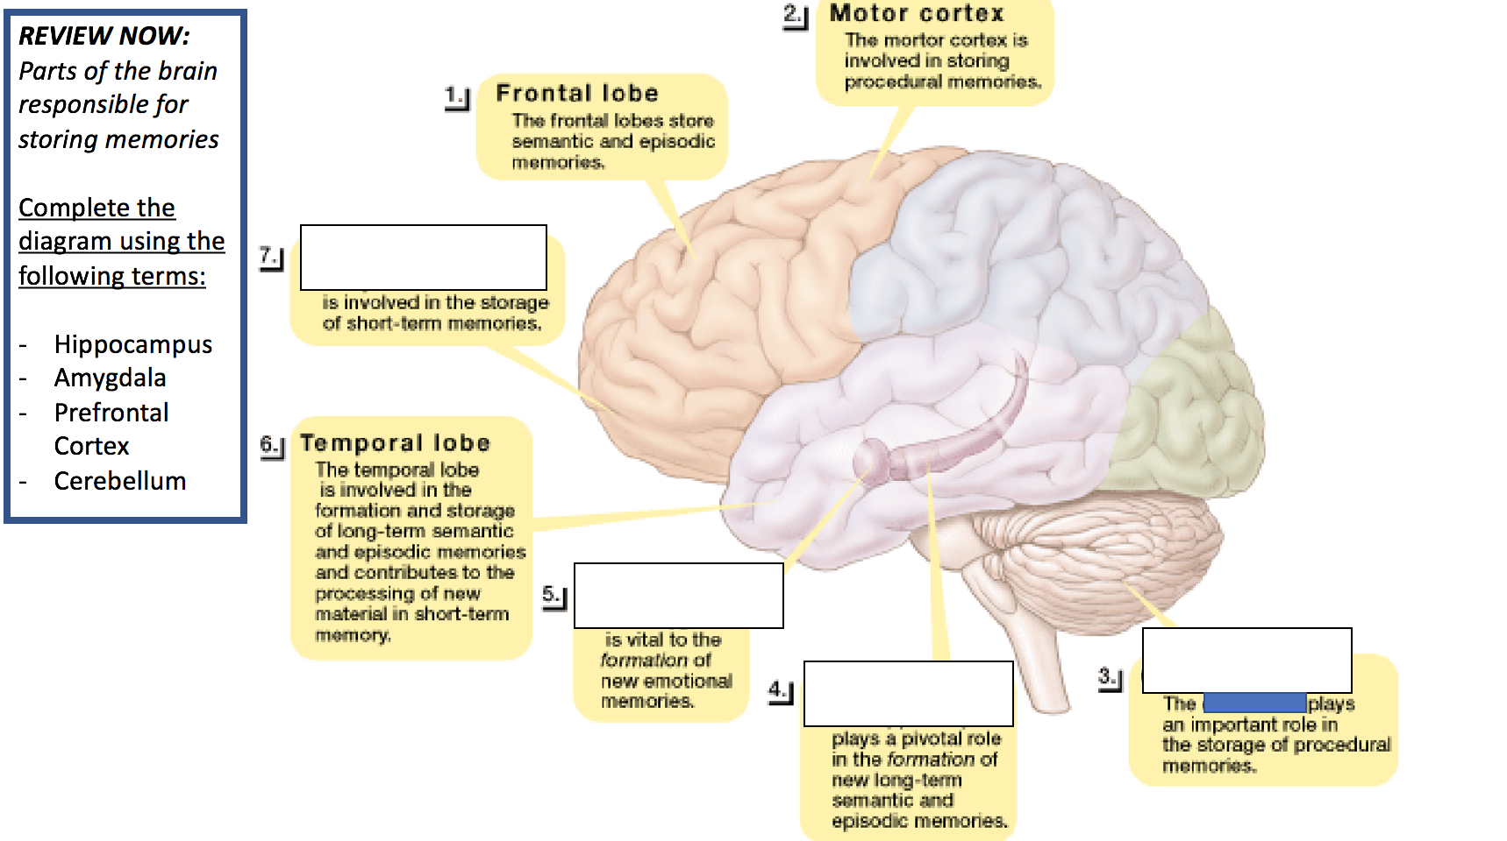
Name___________________________________________________________________Block_____________________Date______________

Memory Unit – Parts of the Brain & Memory

