Name_______________________________________________Block____Date________________
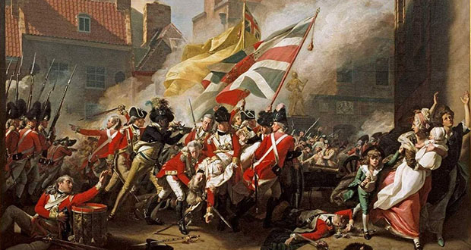
Do Now – The War for Independence, Pre-Trenton

Pt. 1 – Review Strengths + Weaknesses

- Professional well-trained army and navy = __________________________________
- Poor political leadership and military strategy = _____________________________
- Army always short of men, food, supplies, guns, and gunpowder _________________
- Low domestic support for the war = ____________________________________________
- ‘Home Field’ advantage = ______________________________________________________
- Inferior Army and Navy = _____________________________________________________
Pt. 2 – Review Early Battles
- Victorious at the Battle of Lexington = _______________________________________
- Victorious at the Battle of Bunker Hill = _____________________________________
- Won a ‘moral victory’ at the Battle of Bunker Hill = __________________________
- Victorious at the Battle for New York = ____________________________________
Pt. 3 – Big Problems for the Continental Army
(Brainstorm + List at least three serious problems the Continentals face after the battle for New York)

Pt.4 – Preview – Traits of a Good Leader
Directions – with your partner, brainstorm and list traits that are common among good leaders.
