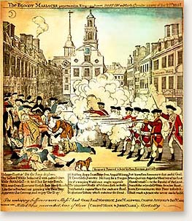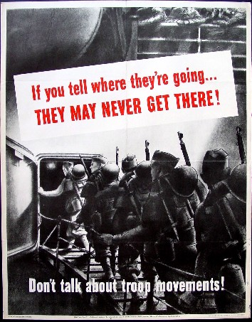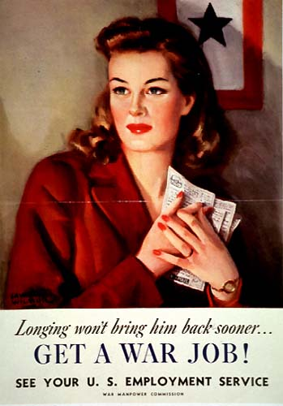
PROPAGANDA POSTER INSTRUCTIONS
You and your partner and partners will create a propaganda poster that tries to persuade people to your point of view. You will create the poster over one of the following events that led to the American Revolution. Only one topic per hour, first come first serve.
- Proclamation of 1763
- Sugar Act
- Stamp Act
- Joining the Sons of Liberty
- Invitation to the Stamp Act Congress
- Writs of Assistance
- Townshend Acts
- Joining the Daughters of Liberty
- Boston Massacre
- Tea Act
- Boston Tea Party
- Coercive / Intolerable Acts (Boston Harbor Act, Quartering Act, Quebec Acts, Massachusetts Governance Act, Administration of Justice Act)

Once you have chosen your topic and gotten it approved by your teacher you must decide next whether your poster will be from the British Point of View or the Colonial Point of View. Identify your poster in the upper left hand corner as being either from the British Point of View or Colonial Point of View and also place a small Union Jack flag or “Don’t Tread on Me” flag to help identify its point of view. Remember the point of your poster is to persuade others to your point of view.

RUBRIC
- In-class Participation: 25% of Grade
- Pre-Poster Worksheet: 25% of Grade
- Accuracy of Information: 25% of Grade
- Persuasive element of Poster: 25% of Grade

GROUP MEMBERS: ______________________________________________________________
______________________________________________________________
______________________________________________________________
______________________________________________________________

Topic: ______________________________________________________________________

Point of View: ______________________________________________________________________

ROUGH DRAFT OF POSTER IN THIS BOX BELOW:

