Name: Block:
US HISTORY – REFORM IN AMERICA
Do Now: Think – Write - Pair - Share
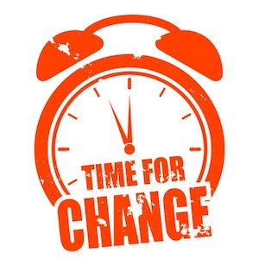
- What elements of American society today are in need of change (reform - for the better)?

