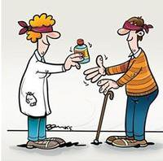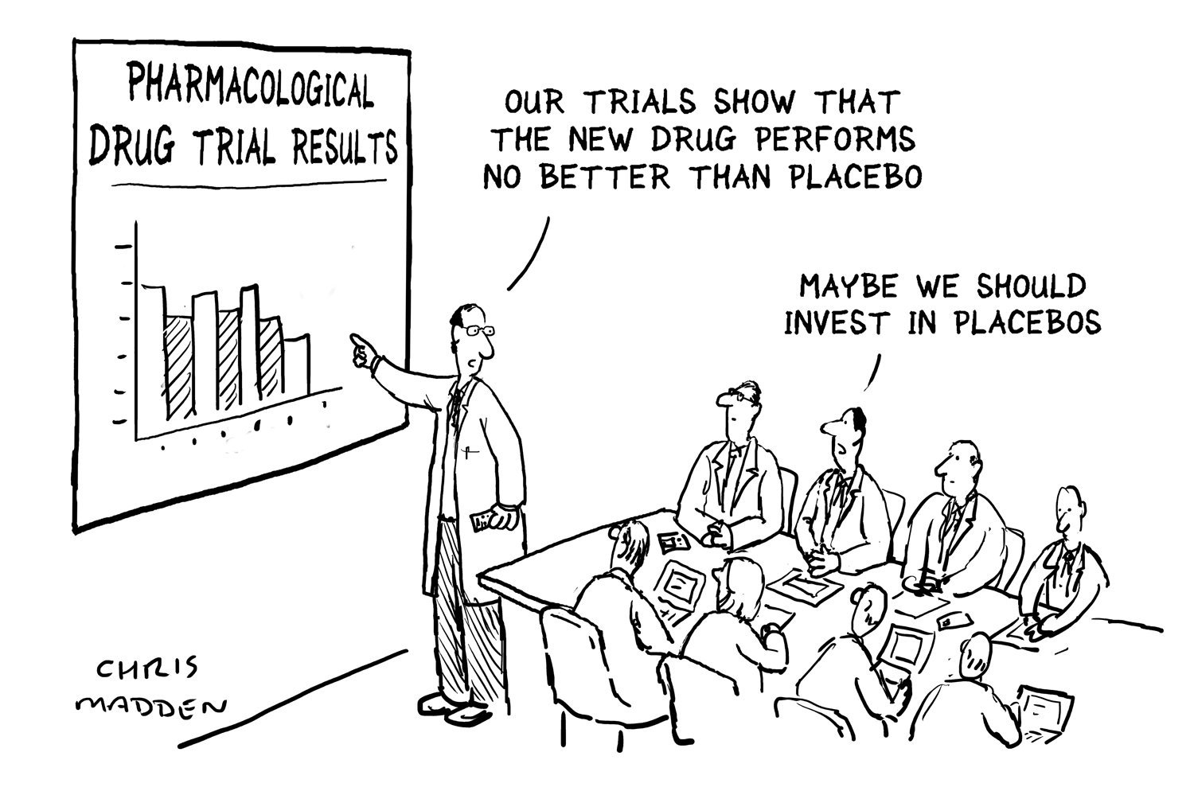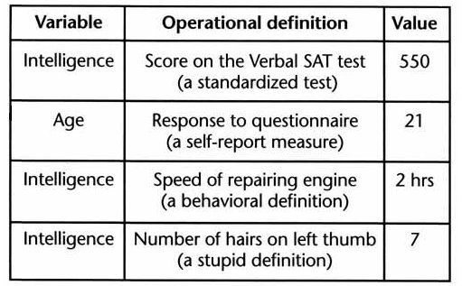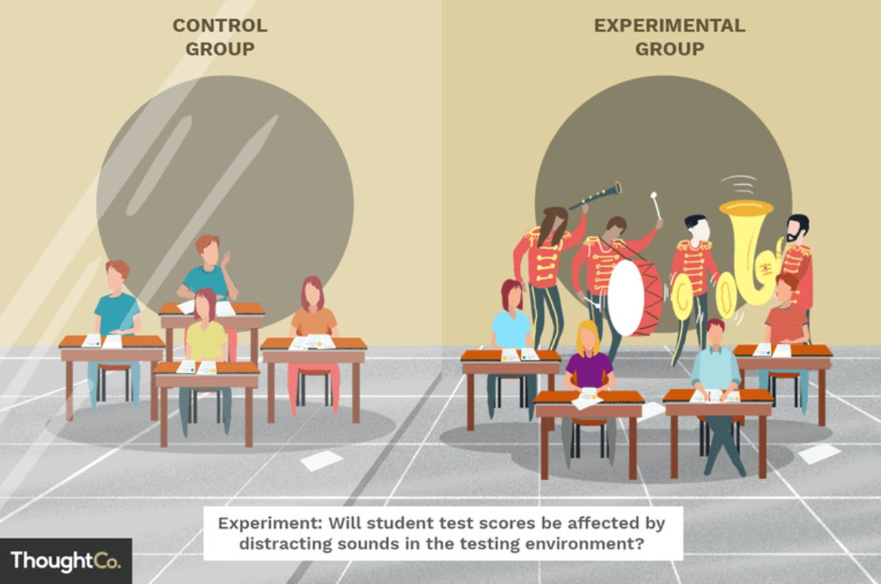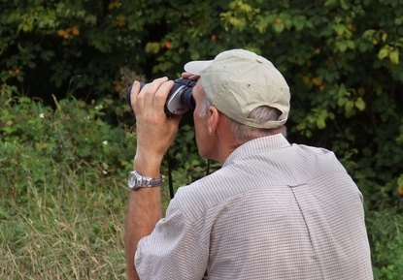**Research Methods in Pictures**

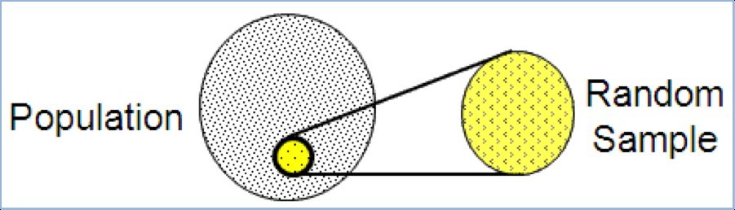

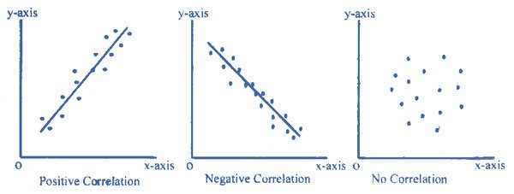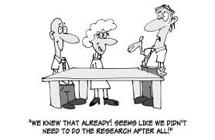

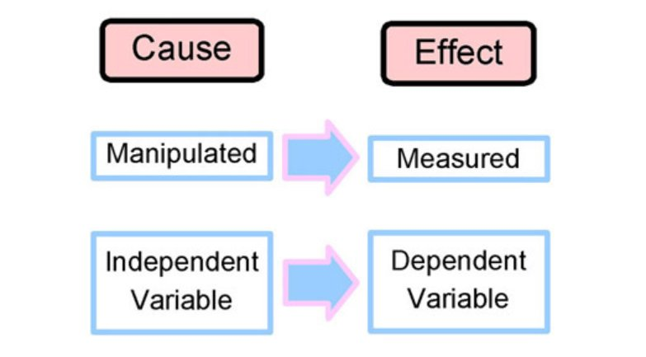

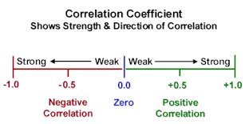

**Directions – Each picture relates to a concept in Research Methods & Statistics. Label the picture or fill in the missing word.**

**Word bank:**

Correlational Coefficient

Double-blind Design

Placebo Effect

Independent Variable

Experimental Design

Naturalistic Observation

Operational Definition

Scatterplots

Hindsight Bias

Random Sample