Name___________________________________________________________ Block___________________

AP Psychology – T. Cummings – Research Methods Review
Selfie Posting May Do More Harm Than Good

For young women, posting selfies decreases confidence and increases anxiety.

Posted Sep 04, 2018 – Psychology Today -- Renee Engeln Ph.D. - Northwestern University
In 2015, a statistic about social media use captured the Internet’s attention: "More people have died of selfies than shark attacks this year.” To be fair, very few people die of either selfies or shark attacks. But a wave of research continues to suggest that social media use can be a significant impediment to mental health. A new study points specifically to selfies as a mood and confidence-lowering activity.
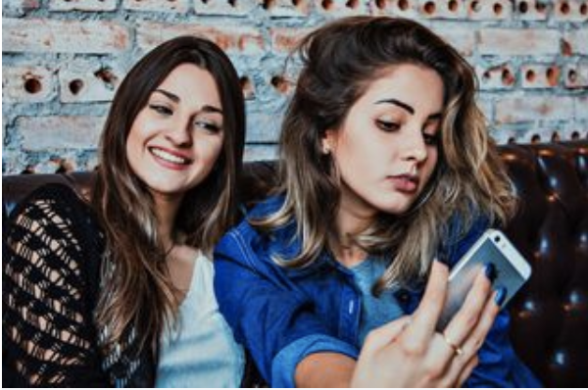
Social media use has been linked to depression, anxiety, body dissatisfaction, and increased focus on appearance. These effects are fairly broad, but they seem to hit young women (who are the heaviest users of social media) especially hard. Yet many of the studies showing an association between heavier social media use and decreased mental health are correlational. As any of my students can quickly tell you: Correlation does not equal causation. In other words, just because social media use is correlated with negative outcomes doesn’t mean that it caused those outcomes. It’s possible that things like depression, anxiety, and poor body image actually drive greater social media use instead of the other way around. If you feel depressed, you might try to connect with people online to alleviate feelings of sadness. If you’re struggling with poor body image, you might try to post attractive pictures of yourself in order to hear positive feedback from others about how you look.

If we truly want to understand the causal effects of social media use, we need to look at the results of carefully conducted experiments in which participants are randomly assigned to conditions. A recent study published in the journal Body Image used this type of experimental design to take on one of the most vilified forms of social media activity — posting selfies.
First, some background. Selfies are often used as a form of what’s called impression management. Any time you’re trying to influence others to see you the way you want to be seen, that’s impression management. Everyone engages in impression management. Social media posts are just one of the many ways people do this.

Interviews with young women reveal that impression management is one of the major reasons they use social media. To be certain, young women are not the only group that uses social media this way, but young women do post more pictures of themselves than other demographic groups. One recent survey of women between ages 16 and 25 in the UK found that many spent several hours a week taking, editing, and posting selfies.

So, back to the research at hand. A group of 113 Canadian women between the ages of 16 and 29 participated in the study led by researchers at York University. When the women arrived, researchers gave them an iPad and took them to a private space. The participants completed several measures of mood and how they felt about themselves. Each woman was randomly assigned to one of three different conditions. In the “Untouched Selfie” condition, the researchers asked the women to take a single photo of their face and post it to either their Facebook or Instagram profile. In the “Retouched Selfie” condition, the women were allowed to take as many photos of themselves as they wanted and were shown a photo editing app they could use to alter the photo before posting it. In the control condition, women read a news article on the iPad about travel locations and didn’t take any pictures or log in to any social media accounts.

Results showed that it didn’t matter whether the women were allowed to retouch their image. Both of the selfie-posting groups showed increases in anxiety and decreases in confidence relative to the control condition. They also felt less attractive after posting a selfie. Though some variables (like depression) did not seem to be affected by posting a selfie, none of the variables measured showed any evidence of a positive psychological effect of selfie posting.

What should we make of these findings? First, it’s essential that young women (or anyone!) not be shamed for their social media behavior. It’s not fair to ask women to live in a world where their appearance is under such constant scrutiny, yet expect them not to react to these pressures. In addition, some women may find the process of posing for, editing, and posting selfies fun or empowering. But it’s worth considering the fact that many of the activities we engage in that might seem fun in the moment can also have a negative impact on our mental health and well-being. Particularly for young women who might already be vulnerable to eating concerns, anxiety, or depression, these findings suggest it might be a good idea to limit selfie posing and posting.
*Study: "Selfie" harm: Effects on mood and body image in young women, 2018. (Mills JS1, Musto S2, Williams L2, Tiggemann M3)
Article Questions:

- What is the correlation mentioned in this study?

- Is this a positive correlation or a negative correlation?

- “______________________ does not equal _____________________!” (BURN THIS INTO YOUR BRAIN)

- What is one potential 3rd variable in this correlation?

- In order to understand the causal effects of social media use, what type of research is needed?

- In York University’s Body Image experiment, what was the experiment’s population?

- What is the Independent Variable (IV)?

- What is the Dependent Variable (DV)?

- What were the two experimental groups (conditions)?

- What was the control group (condition)?

- What was the results of the study?

