Name_____________________________________________ Block________
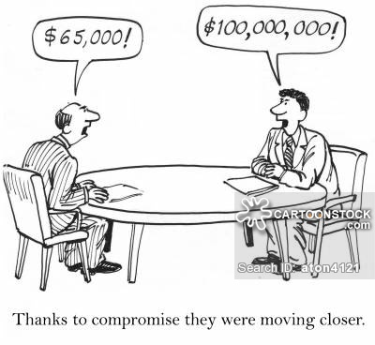

- What method of settling disputes is depicted above?

- In order for a dispute to be settled this way, what do both ‘parties’ need to do?

