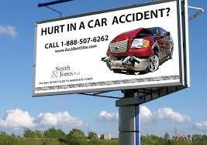**Should Lawyers be allowed to Advertise?**

**Part 1**

**For most of the 20th century, bar associations forbade nearly all forms of attorney advertising; you could be disbarred for peddling your services on anything other than a business card. Bar associations thought big bold ads were unprofessional and would stir up unnecessary lawsuits, drive up costs, and could even result in a decrease in the quality of legal services due to increased competition. In the 1970s, the Supreme Court ruled that such "commercial speech" by lawyers was subject to First Amendment protection, and that was the end of the ban. These days, lawyers are famous for being among the loudest of local advertisers, and our airwaves and billboards are flooded with ads. Many think that there should be a change that limits advertising by lawyers.**

**Directions: List as many arguments (Yes and No) as you can for whether lawyers should or should not advertise:**

|  |  |
| --- | --- |
| **YES** | **NO** |
|  |  |

**Part 2**

**Do you think lawyers should be allowed to advertise? Explain your reasoning.**

**________________________________________________________________________________________________________________________________________________________________________________________________________________________________________________________________________________________________________________________________________________________________________________________________________________________________________________________________________________________________________________________________________________________________________________________________________________________________________________________________________________________________________________________________________________________________________________________________________________________________________________________________________________________________________________________________________________________________________________________________________________________________________________________________________________________________________________________________________________________________________________________________________________________________________________________________________________**