Statistics
Bell Work: Review what you know about correlations! In the space provided, record what letter we use as the correlation coefficient and describe what conclusions we can make about this data.
Sample Size
Variable = n
= -.47598
Data Set
7, 15, 20, 4, 8, 5, 4, 12

Basic Statistical Math
Step 1:
DO NOT PANIC!

Step 2: Arrange the data set in numerical order from smallest to largest. | DO NOT PANIC!  DO NOT PANIC!
Step 3: Calculate the sample size. Add how many data points we have.
Step 4: Calculate the range. Subtract the smallest # from the largest #. Show your work! | n =
Step 5: Identify the mode. Which number has the highest frequency?
Step 6: Identify the median. Which number is the middle of the set?
Step 7: Calculate the mean. Add all #s in the set and divide by the sample size. Show your work!

Calculating the Standard Deviation
Variance: variance measures how far a set of numbers is spread out. A variance of zero indicates that all the values are identical.  - Step 1: Calculate the mean of the data set.  - Step 2: For each number in the data set, subtract the mean and square the result.  - Step 3: Calculate the mean of those squared differences. The result is called the variance. | Coach Lane has 4 student athletes punt a football, and the distances are 36, 38, 41, and 45 feet.  Step 1: Mean = _____  Step 2: (36-mean) ^ 2 = _____  (38-mean) ^ 2 = _____  (41-mean) ^ 2 = _____  (45-mean) ^ 2 = _____  Step 3: Mean of Step 2 #s = _____
Standard Deviation: standard deviation also measures how spread out the data set is; taking the square root restores the variance to the same unit of measurement as the original data  - Step 1: Calculate the variance.  - Step 2: Take the square root of the variance. | Step 1: Variance = ______ (record step 3 from above)  Step 2: √(Variance)= ______
Graph Activities: For the first graph, record which distribution has a higher standard deviation. For all graphs, label where you find the mean, median, and mode.
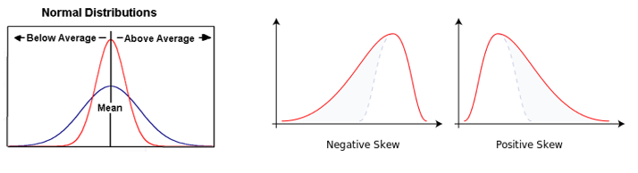

Statistical Significance
Statistical Significance: This number represents the probability that results were obtained by chance. If the significance variable is less than .05%, then the results are statistically significant. This means that the results can be trusted; the data collected did not occur randomly; there is a high probability that the independent variable caused changes in the dependent variable. | - Task: the variable used to signify statistical significance is p. Create a memory clue to remember the definition of “p.”  p
First-person-shooter-task (FPST) is a video game were white and black men were pictured either armed or unarmed. The photos (seen below) show white and black men armed with guns or unarmed (yet, holding a black wallet, cell phone, or can of soda). The video game was developed by Correll, Park, Judd & Wittenbrink (2002) and included various backgrounds like a park or street. Participants were asked to press a “shoot” button when they thought they viewed an armed person and a “don’t shoot” button when the person held a non-threatening object. Psychologists wanted to measure the speed of the participants’ responses as well as their accuracy. At the conclusion of the study, participants had greater speed and accuracy when targets were stereotypic (armed African Americans and unarmed whites).

When it came to speed, participants had up to 850 milliseconds to respond. On average, most responses ranged within 550 milliseconds to 650 milliseconds. Participants pressed the “shoot” button at armed targets more quickly when the actor was Black than if he was White (p < .005). Participants took longer to decide to press the “don’t shoot” button when there was an unarmed Black target versus White (p < .005).
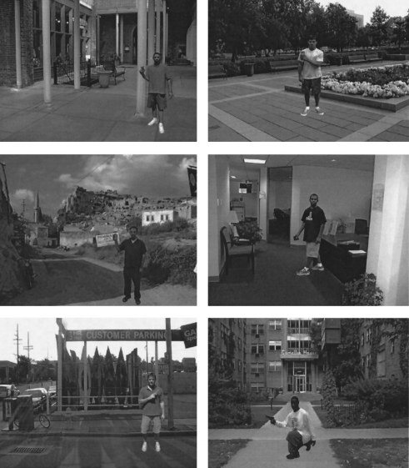

Hitting “don’t shoot” when there was actually a gun was considered a mistake or “miss.” Hitting “shoot” when there was no gun was classified as a mistake, but called a “false alarm.” In general, participants made more “false alarms” for African American targets than White (p < .01).
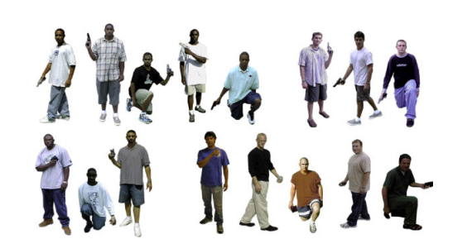
Wrap Up: Explain what “statistical significance” means in the context of this study.
_________________________________________________________________________________________________________________________________________________________________________________________________________________________________________________________________________________________________________________________________________________________________________________________________________________________________________________________________________________________________________________________________________________________________________________________________________________________________________________________________________________________________________________________________________________________________________________________________________________________________________________________________________________________________________________________________________________________________________________

