AP Psychology Warm-Up – Stats Review
Descriptive Stats - are more appropriate for summarizing, organizing, characterizing data/sample.
- Measures of Central Tendency
  - Mean (μ) --> more appropriate when data are not skewed OR are normally distributed.
  - Median --> more appropriate when data are skewed OR there are extreme scores.
  - Mode --> mode = most
- Measures of Variability
  - Standard Deviation (σ)
  - Normal Curve + Percentiles
  - Range

Inferential Stats - more appropriate for comparing differences OR finding statistical significance OR drawing conclusions OR interpreting OR finding if events happened by chance.
- Statistical Significance
- p < .05 (meaning there’s a 95% likelihood the results are NOT due to chance)

#1 - Find the standard deviation in the following list of numbers:

List: 3,4,5,10

#2 -
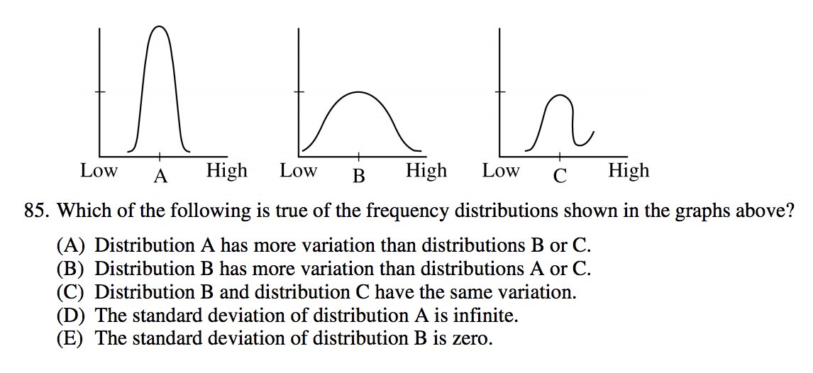
Figure 1 - via 2012 Released Test

