Name: _______________________________________________________ Block: __________
U.S. History I

Fighting for Independence
Strengths and Weaknesses of the British and Americans

According to John Adams, about a third of the colonists were Patriots. Another third were Loyalists, or Tories, as the Patriots called them. Adams believed that the remaining third of Americans were neutral in the war. While the population may have been divided, each of the two sides in the war had its own strengths and weaknesses.

The British
Britain’s main strength was its well-equipped, disciplined and trained army. In addition, the British navy was the world’s finest. It provided support by transporting and landing troops and protecting supply lines at sea.

The British also received help from a number of sources. Roughly 50,000 Loyalists fought with the British army. Some African Americans, largely in the South, also helped Great Britain. The British promised freedom to all slaves who served their cause.

Additional help came from Native Americans. Most Indian nations believed an American victory would be harmful to their interests. In the South and West, the Creeks, Cherokees, and Shawnees fought alongside British and Loyalist forces. In the North, Mohawks, led by Joseph Brant, and most other Iroquois nations sided with the British.

The British also hired 30,000 mercenaries, foreign soldiers who fight for pay. The colonists called these troops “Hessians” because most of their officers came from the German province of Hesse.

On the other hand, the British also had their problems. The war was not popular in Great Britain. Many British citizens resented paying taxes to fight the war and sympathized with the Americans. British troops had to fight in hostile territory and British commanders resisted adapting their tactics to conditions in America.
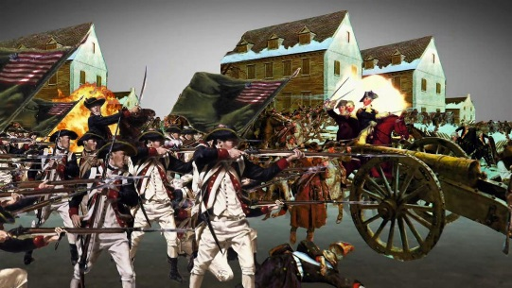
The Americans
The very things that were the British weaknesses were American strengths. Patriot forces were fighting on their own territory. Many of their officers were familiar with the tactics that had worked in the French and Indian War. George Washington, in particular, had proved to be an exceptional commander.

For much of the war, the Americans lacked a well-supplied, stable, and effective fighting force. New recruits were constantly arriving while experienced soldiers, their time of service up, were heading home. As he tried to plan strategy, Washington never could be sure how many troops he would have.

More African Americans served in the Patriot cause than supported the British. Washington’s army had some all-black units, but more often, African Americans served in white units.

from America: Pathways to the Present

Use the text on the last page to complete the chart below.

American Strengths | American Weaknesses |  | British Strengths | British Weaknesses

Based on the chart above, which side had the advantage going into the Revolutionary War? In other words, which side looked like it was likely to win this war? Explain your answer using details from the chart.

__________________________________________________________________________________________

__________________________________________________________________________________________

__________________________________________________________________________________________

__________________________________________________________________________________________

__________________________________________________________________________________________

__________________________________________________________________________________________

__________________________________________________________________________________________

__________________________________________________________________________________________

