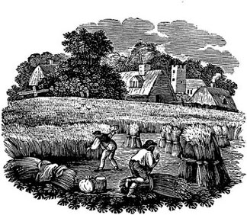
Do Now -- Summary Activity: Colonial America

Climate plays a vital role in shaping the history, culture, economy, and even the character of a particular place.
______________________________________________________________________________________

Read the three regional climate descriptions. Then decide which region is being described below.

- New England:  Cold, with long, harsh winters and short, mild summers; rocky soil, rather poor for most crops | - The middle colonies: cold winters but not as harsh as New England’s; summers longer and hotter than New England’s; rich soil | - The Southern colonies: warmest climate – long, hot summers and short, mild winters; rich soil

____ 1. These were known as the Bread Colonies because they produced so much grain.
____ 2. Towns were slow to develop; most people lived on large farms.
____ 3. This region’s growing season was shorter than South Carolina’s, but longer than Connecticut’s.
____ 4. People turned from farming to the sea to earn their living.
____ 5. Pneumonia was a risk factor for people who didn’t have good shelter.
____ 6. Farming was very profitable, so this area never fully developed its other natural resources.
____ 7. Both farming and fur trading were very profitable in this region.
____ 8. This area had the shortest growing season.

