NAME: AP PSYCH – Unit 2: BioPsych

The Brain in Three Sections – Student Note Option

(Central Nervous System = Brain & Brainstem)

I – Hindbrain
II – Midbrain
III – Forebrain

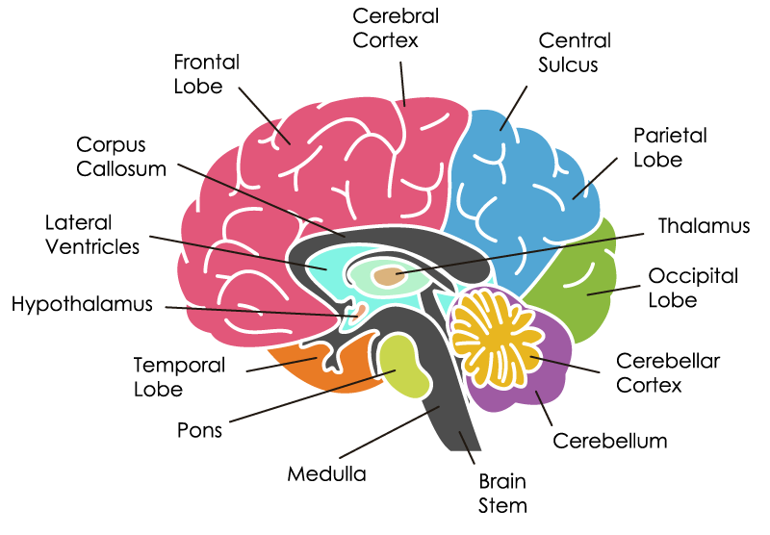
- Hindbrain – lower portion of brain, responsible for vital functions, heart rate, respiration, and balance. The lower brain functions do not require any conscious thought or effort-we are not aware of these activities.

  - Medulla –

  - Pons –

  - Cerebellum –

- Midbrain – Involved in vision, hearing
  - Reticular Activating System –

- Forebrain - region of the developing vertebrate brain
  - Thalamus –

  - Hypothalamus –

  - Limbic System –

  - Cerebrum (Cerebral Cortex)
    - Two Hemispheres, Four Lobes (FPOT)
      - Frontal Lobe -
        - Motor Cortex -
        - Broca’s Area -
      - Parietal Lobe -
        - Somatosensory Cortex -
      - Occipital Lobe -
      - Temporal Lobe -
        - Wernicke’s Area -
    - Thalamus –

    - Hypothalamus –

    - Limbic System -

