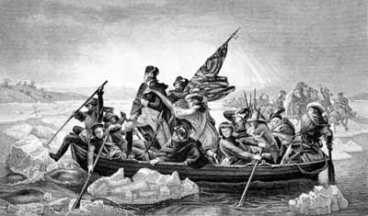
The Crossing

A mere six months after the colonies declared independence from Britain and the crown, the American army was decimated. Overrun by the British in battle after battle, chased from New York to the hinterlands of New Jersey along the Delaware River between New Jersey and Pennsylvania, ill-equipped and underfed, the Continentals were hardly seen as a threat to the might of the British Empire in the Americas. It is December 1776.

Key Characters:

General George Washington
Commander of the Continental Army
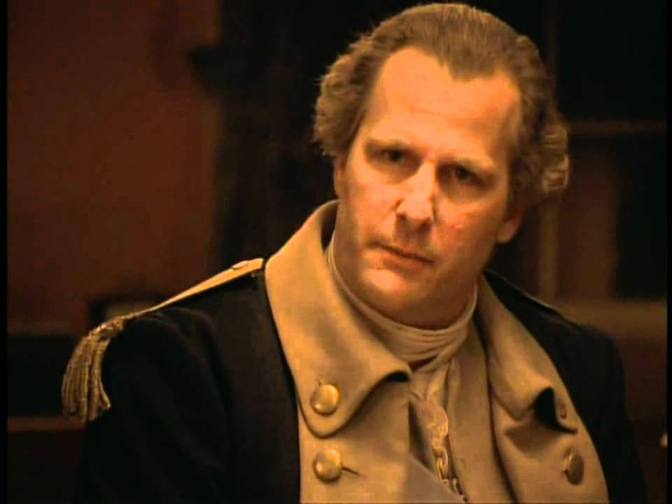

Colonel John Glover
Commander of the Marblehead Fishermen
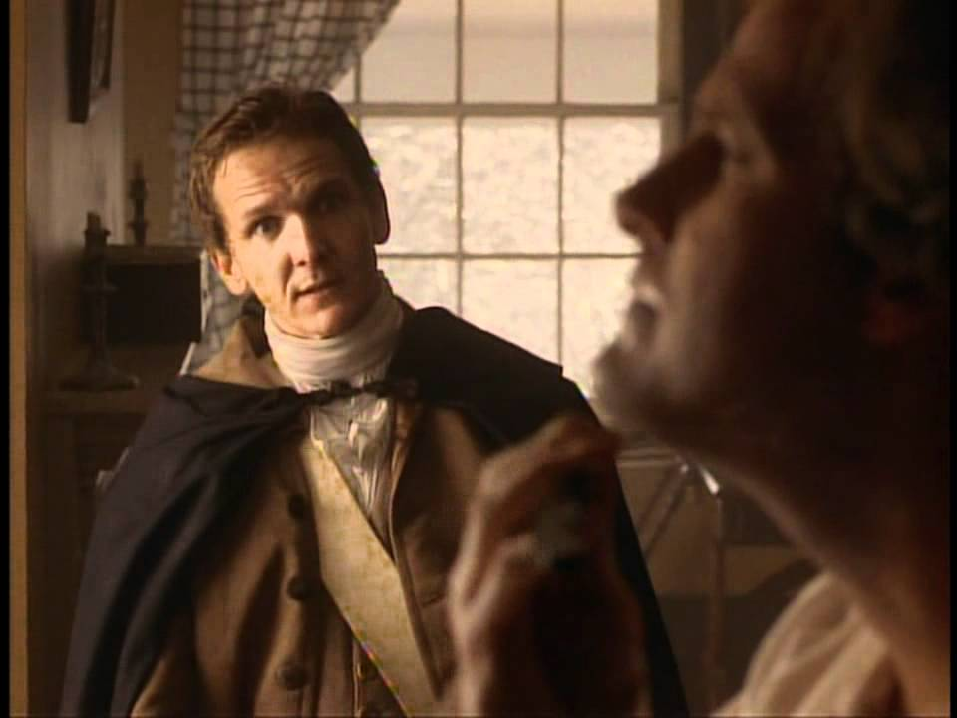

Alexander Hamilton
19-year-old officer under Washington
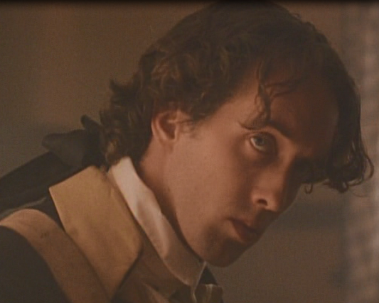

General Horatio Gates
Patriot Commander and rival of Washington
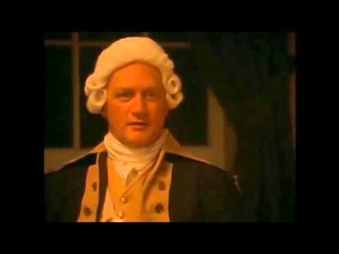

General Hugh Mercer
Washington's trusted aide
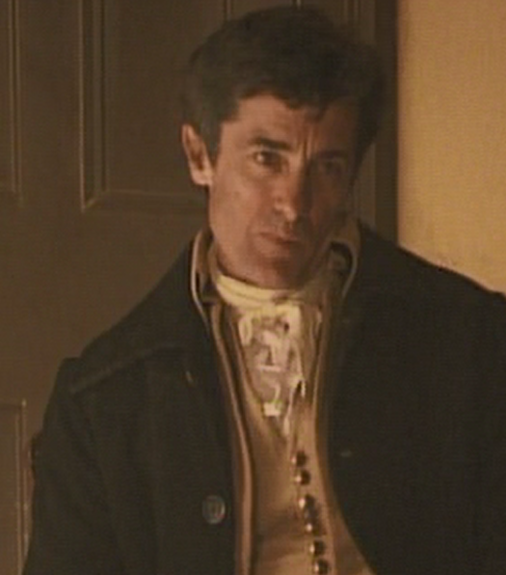
- It is important to PAY ATTENTION to what these characters say in the movie.
- The details are IMPORTANT and you need to listen CAREFULLY, or you will miss the main points!
- Your paper will rely upon these details.

General Henry Knox
Commander under Washington
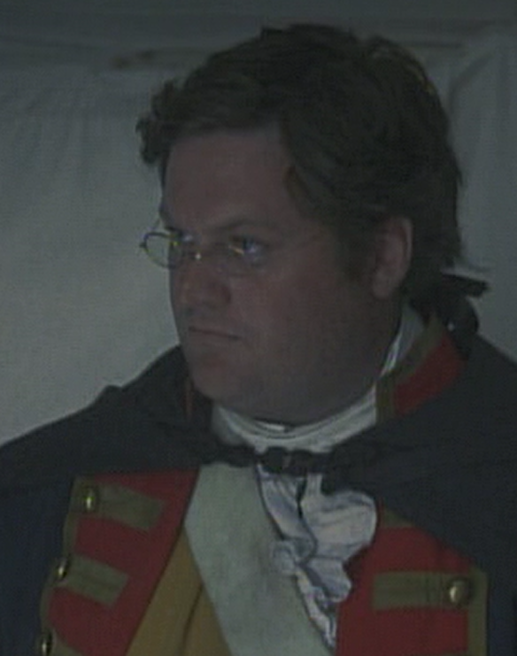

Colonel Rahl
Hessian commander
