Name ______________________________________________________ Block:______________
US History I

The French and Indian War

Main Idea (pg. 85): _________________________________________________________________________
__________________________________________________________________________________________
__________________________________________________________________________________________
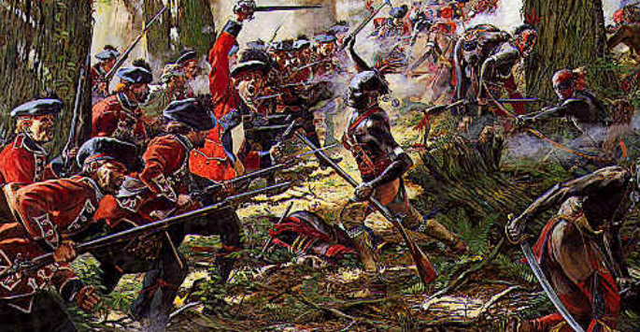

Key Terms/ People
French and Indian War: ______________________________________________________________________
__________________________________________________________________________________________

George Washington: ________________________________________________________________________
__________________________________________________________________________________________

William Pitt: _______________________________________________________________________________
__________________________________________________________________________________________

Sugar Act: ________________________________________________________________________________
__________________________________________________________________________________________
Directions: Fill out the charts below about the French and Indian War.
Motivations/ Causes of the War
- Why did France and Britain fight this war? | - Why did the British colonies fight? | - Why did the Native Americans fight?

Outcomes/ Effects of the War
- Who was winning early in the war? Why?  (pgs. 86-87) | - How did Great Britain eventually win the war? What did they win by defeating the French?  (pg. 87)
- After France lost the war, what did Ottawa leader Pontiac do? How was he defeated?  (pg. 88) | - What was the Proclamation of 1763? (pg. 88)
- How did the French and Indian War lead to conflict between American colonists and Great Britain?

